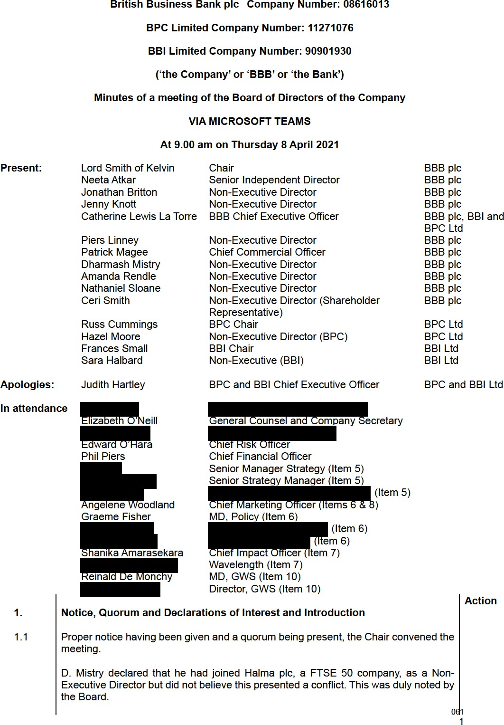

Minutes

  - It was agreed that the minutes of the meeting held on 4 March be represented to the Board at its next meeting as several changes were suggested, notably that the section relating to Risk Appetite required more detail.

Action Points/Matters Arising

  - C. Smith advised that he would be resigning from the Board in the next few weeks as he had accepted a position at the Department of International Trade. An alternative Shareholder Representative would be appointed.
  - The Chair reported that A. Rendle and S. Halbard would be retiring from the Boards of BBB plc and BBI Ltd respectively in September 2021 and that a process to recruit replacements would commence.

  - It was the intention that P. Linney and R. Cummings would be reappointed for a further term subject to Secretary of State approval.

  - Secretary of State approval had been given to the reappointment of Lord Smith of Kelvin as Chair for a further term.
  - It was noted that outstanding actions were not due until the May meeting with the exception of reputational risk and 2021/22 Budget Business Plan, which would be discussed later in the meeting.

Business Update

  - C. Lewis La Torre began by advising that the Chancellor of the Exchequer had received advice on the BEIS/HMT review of the Bank and was supportive of the revised mission. He had requested further information in respect of the climate change objective and net zero deliverables which are in preparation.
  - C. Lewis La Torre reported that the Recovery Loan Scheme had been successfully launched on 6 April. P. Magee added that a number of lenders had already been accredited and that the media coverage to date had been largely factual.

  - C. Lewis La Torre advised that a meeting with herself, Lord Agnew and Paul Scully had been held primarily to discuss the use of consultants during the delivery of the Covid-19 schemes. C. Lewis La Torre explained why this had been necessary and for what specific purposes consultants had been used. The matter of Cabinet Office controls and exemptions had also been raised and C. Lewis La Torre informed Lord Agnew of the governance arrangements in place at the Bank. Minister Scully proposed a meeting between Lord Agnew and Lord Smith to discuss this further.

  - ​

BRC. 462
C. Smith added that the Bank’s operational costs were being examined more generally by BEIS and HMT. He expected that the BEIS-commissioned review being carried out by Oliver Wyman would be helpful in this regard. In response to a query, C. Lewis La Torre advised that a preliminary draft of the report’s recommendations had been shared with her by Oliver Wyman. She agreed to circulate the final report to Board members once issued by BEIS.

  - ​

BRC. 463

  - ​
There was discussion regarding the Bank’s new mission statement with P. Linney suggesting a change of the wording. It was agreed that C. Lewis La Torre would explore whether it would be possible to make any changes at this late stage.

C. Lewis La Torre then provided an update on the Strategic Investment Partnership (‘SIP’) which was announced jointly in March by HMG and the UAE. This is a multi-billion investment programme between the two countries which will cover several
investment themes. Mubadala, Abu Dhabi’s Sovereign Wealth Fund, will initially 062
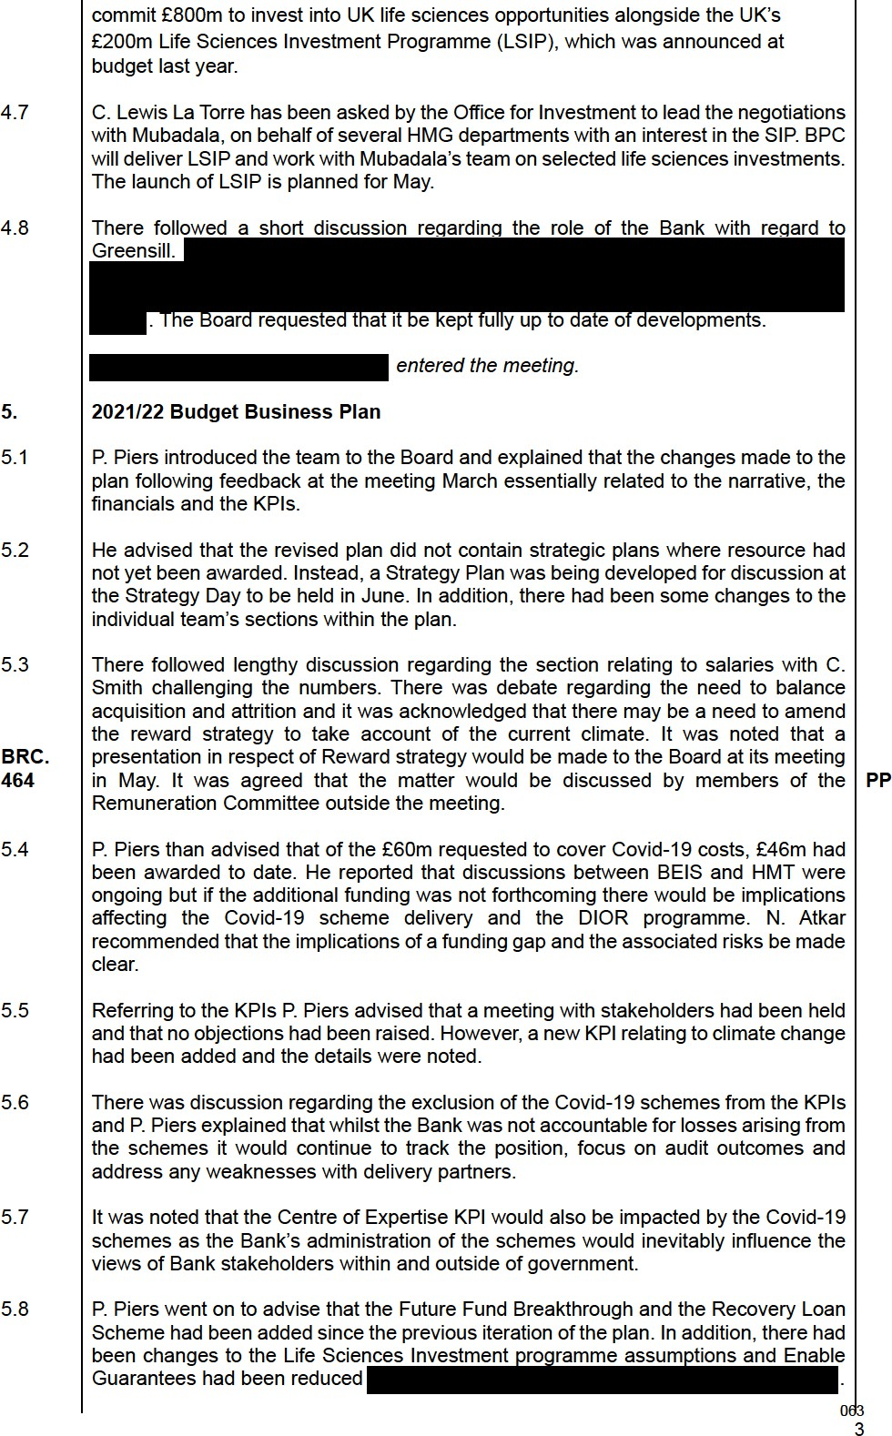
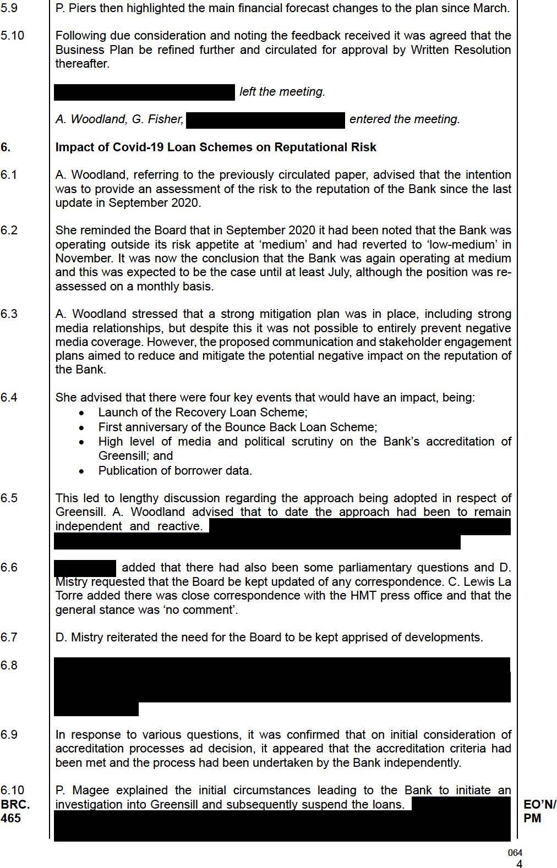
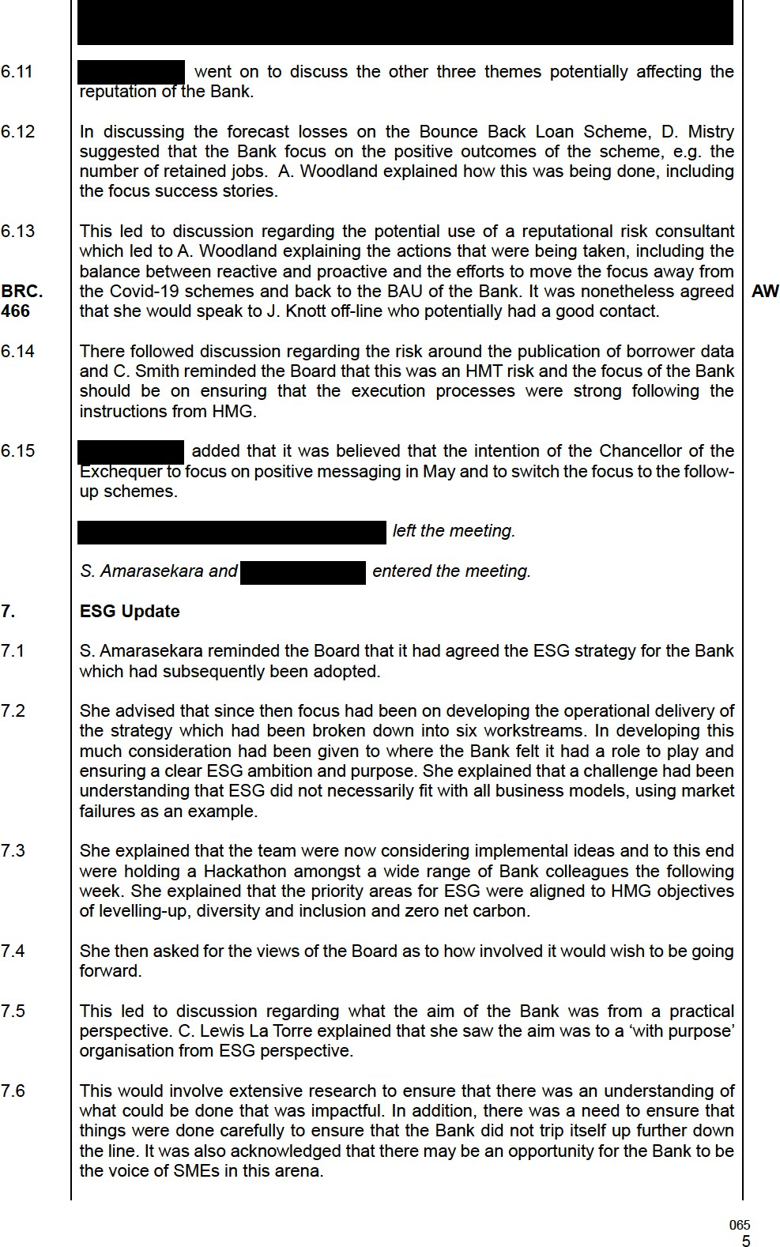
  - It was acknowledged that this could lead some difficult decisions and discussions with lenders in the future.

  - There followed lengthy discussion regarding the need to ensure that any initiatives should be sustainable and that prioritisation would be necessary.
  - The Board noted the progress being made and it was agreed that an update would be provided in due course.
S. Amarasekara and left the meeting.

DIOR Programme – Governance and Assurance Recommendations

  - A. Woodland explained that the purpose of the paper was to provide an update to the Board on the DIOR programme and to seek confirmation that it was content with the proposed recommendations around governance and assurance measures.
  - She explained that the programme had been broken down into 4 workstreams being Data, IT, Outsourcing and Supplier Management and Risk Management.

  - Each of these areas had SRO, who was an Executive Committee member, who would report into the Programme Board. This would provide governance and oversight across all workstreams and was chaired by A. Woodland. The benefits of this approach were noted.

  - The first, second and third lines of defence as detailed in the paper were then explained. This led to A. Woodland explaining the options available for the third line of defence which was providing assurance to the Board and the Shareholder.
  - Following due consideration, the Board AGREED to support option two which was to ‘adhere to existing, robust Risk Management Framework built on 3 LOD model, with additional, external, independent assurance’.

A. Woodland left the meeting.

Board Evaluation – Skills Matrix

  - The content of the paper was noted and N. Atkar advised that the majority of actions had been completed.

  - The detail contained in the skills matrix noted and N. Atkar advised that this would be reviewed by the Nomination Committee and would be taken into consideration when looking to appoint new directors.
R. de Monchy and entered the meeting.

Project Tom – Enable Guarantee Approval

  - R. de Monchy explained that the purpose was to ask the Board to consider whether it would recommend that the Secretary of State for the Department for Business, Energy and Industrial Strategy enter into the proposed ENABLE Guarantee transaction with ESF Capital Limited.

  - He reminded the Board of the background to Enable guarantees generally as well as the particular transaction being proposed, which had been approved by the Investment Committee in February.

  -  explained the transaction in detail including the reasons for using an Enable Guarantee.
  - Noting the content of the paper and the Investment Committee approval the Board, following due consideration RESOLVED to agree to:
    - recommend that the Secretary of State for the Department for Business, Energy and Industrial Strategy enters into this proposed ENABLE Guarantee transaction with ESF Capital Limited, and
    - delegate approval for sign-off of the final terms, transaction documents and deliverables to the BBFSL Investment Committee and the appropriate delegates.
R. de Monchy and left the meeting.

SUL Procurement

  - P. Magee explained that the Board was being asked to approve the extension of the existing contract between SUL and Transmit Start-Ups (TSU) Ltd for a period of 12 months to March 2022 to align with all other SUL Delivery Partner contracts.

  - It was noted that the anticipated contract value was a maximum of £2.1m.

  - The background was noted and following due consideration, the Board RESOLVED to approve the 12-month contract extension, with the anticipated contract value of up to a maximum of £2.1m for TSU for the FY21/22.

Any Other Business

Directors and Officers Liability Insurance
  - advised that quotes had been received from Directors & Officers Liability Insurers and the rates had dramatically increased, in line with those across the market generally. The premium the previous year had been approximately £30k for £10m cover. The quote for 2021/22 was approximately £35k for £5m cover and £60k for
£10m.

  - Following due consideration, the Board RESOLVED to agree that cover of £10m be continued with and instructed to arrange renewal accordingly.
  - There being no further business the meeting ended.
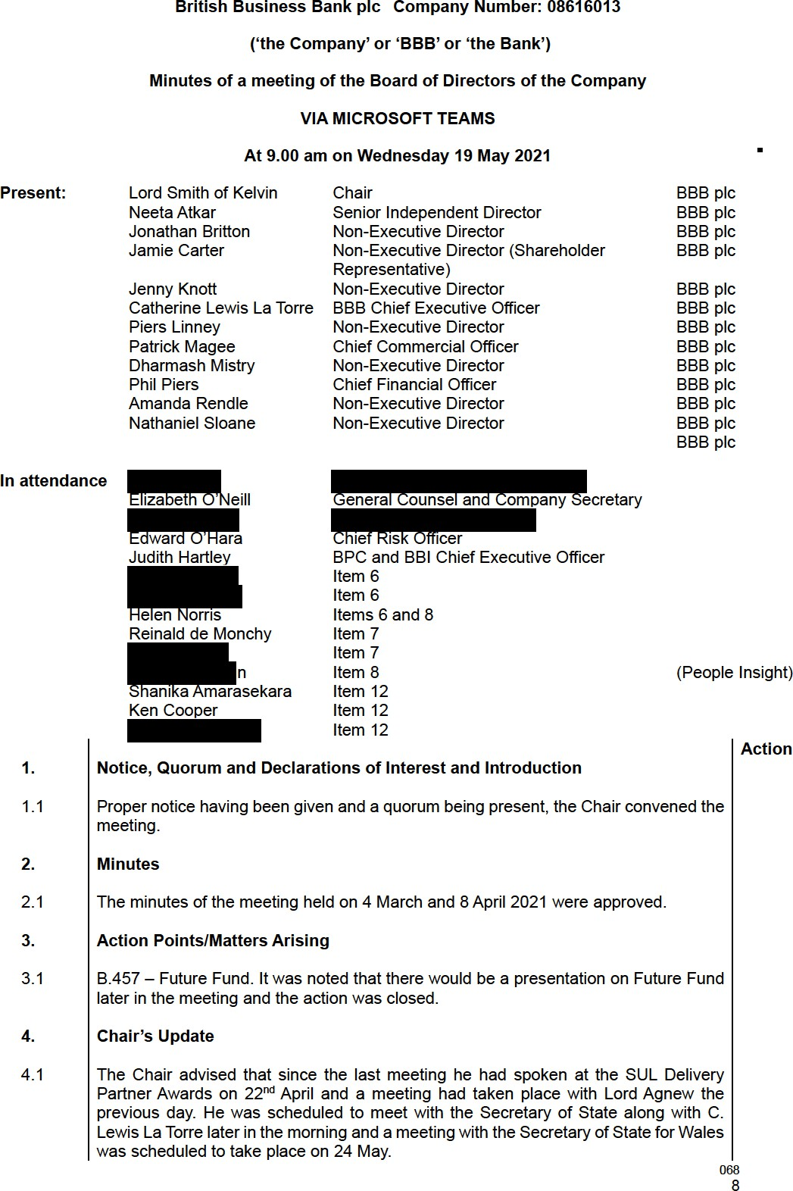

Board Committee Updates

Nomination Committee
  - The Chair advised that a meeting of the Nomination Committee had been held on 15 April at which the following matters had been discussed:
  - • Review of the Board Skills Matrix:
    - Board appointments update including the CFO;
    - The detail of conflicts of Interest Register was noted; and
    - Discussions regarding the appointment of a permanent CEO had begun.
Remuneration Committee
  - A. Rendle advised that the Committee had met on 28 April 2021 and had considered the following matters:

  - • Interim review of the Bank’s performance against KPIs;
    - Agreed there would be a salary freeze in line with the public sector except for colleagues earning less that £24,000 where a £250 salary increase could be made;
    - Approval was given to pay Band 4-7 personal performance element of bonuses in June whilst the corporate performance element and the whole bonus/LTIP for Band 3 and above would be paid in September;
    - The Committee was advised that BEIS had approved 7 additional slots above the Prime Minister’s salary but approval by HMT was still outstanding;
    - There was discussion regarding a review of LTIP which would now form part of a wider remuneration review. It was nonetheless agreed that BPC would be treated separately from this;
    - It had been noted that the executive team objectives would be completed in June/July.

Audit Committee
  - J. Knott advised that the Committee had met the previous day. The first half of the meeting had focussed on internal audit.
  - There had been lengthy discussion regarding the KYC, AML & Support Risk Management framework audit which had received an ‘inadequate’ rating. It had been noted that that there had been no regulatory or legal breaches identified but a number of issues had been raised.

  - J. Knott advised that these seemed to be thematic issues across many areas and she felt that the underlying issues appeared to be related to whether several areas were fit for purpose given the increased size of the Bank including the operating model, the review of critical purposes and the risk defence lines.

  - It was nonetheless noted that remediation actions were underway to address the issues raised including a review of the policy, work on the target operating model and a review of the role of the Investment Committee.
  - There had also been discussion regarding the resource and funding constraints, and it was noted that approval of the Business Plan by HMT, and therefore funding, was expected within the next few weeks.

  - There had followed discussion regarding transparency, and it had been agreed that the Audit Committee would receive early warning should there be any significant negative findings in relation to internal audits. Furthermore, any particularly concerning matters would be highlighted to the Board.
  - There had also been discussion regarding the other internal audit reports, action tracking, fraud and speak up and the internal audit end of year report had been noted.

  - The second half of the meeting had focussed on valuation projects. Approval had been given to a change in the policy for SULCo. There had been discussion regarding the need to avoid over optimism and D. Patrick had agreed to assist with ensuring alignment between the production of the BBB and BEIS annual report and accounts.
  - Finally, it had been agreed that training sessions on debt scheme ECLs and the Future Fund would be arranged. All directors could expect to receive an invite in the coming weeks.
The Chair, J. Carter and C. Lewis La Torre left the meeting. , H. Norris and entered the meeting.

Policy Approvals

Speak Up P olicy
  - explained the background to the review of the Speak Up Policy advising that the review had considered the content of the EU Directive, despite it not being incorporated into UK law. As a result of the review, there had been various non-material changes and he confirmed that the policy to did not extend to third parties, in line with general UK practice.
  - There was a query regarding the inclusion of former employees and
advised that they were not included. He did however advise that a review of Speak Up requirements in the UK was due which may result in further changes to ensure that the Policy aligned to other HMG arms-length bodies.
  - In the meantime, the Board RESOLVED to approve the Speak Up Policy as presented.

Standards of Conduct Policy
  - H. Norris advised that the Standards of Conduct Policy was reviewed on an annual basis. As a result of the review there were several non-material changes with the only major change pertaining to the inclusion of contract and other non-permanent staff.
  - Following due consideration, the Board RESOLVED to agree the Standards of Conduct Policy as presented.

DFA Polic y
  - advised that the Board was being asked to consider the approval of annex 6 of the DFA policy, relating to BIP and loss claims, which had previously been agreed in December 2020. He explained that, at the time the annex 6 authority levels were agreed, there had been uncertainty regarding the likely level of BIP and loss claims. Given the expected level of loss claims, likely to arise from July 2021, the existing limits were considered insufficient. The request therefore was that the authorities be scaled up across all grades to align with the likely claims. In addition, the opportunity to clarify the wording had also been taken.

  - There followed discussion regarding the seniority of those able to authorise at the various levels given the size of the payments and explained the additional checks and controls in the whole finance process.

  - ​
J. Knott requested the detail of the whole operating model across this area and it was agreed that this would be provided outside the meeting.
/PP
  - In the meantime, the Board RESOLVED to approve the changes to the DFA Policy appendix 6, with the exception of a relaxation to the authorities to approve bank payments, which was considered excessive relative to the change in the invoice approval limits. It was agreed that this would be revisited and a revised proposal, taking
into account the concerns, would be put to the Board in due course. PP
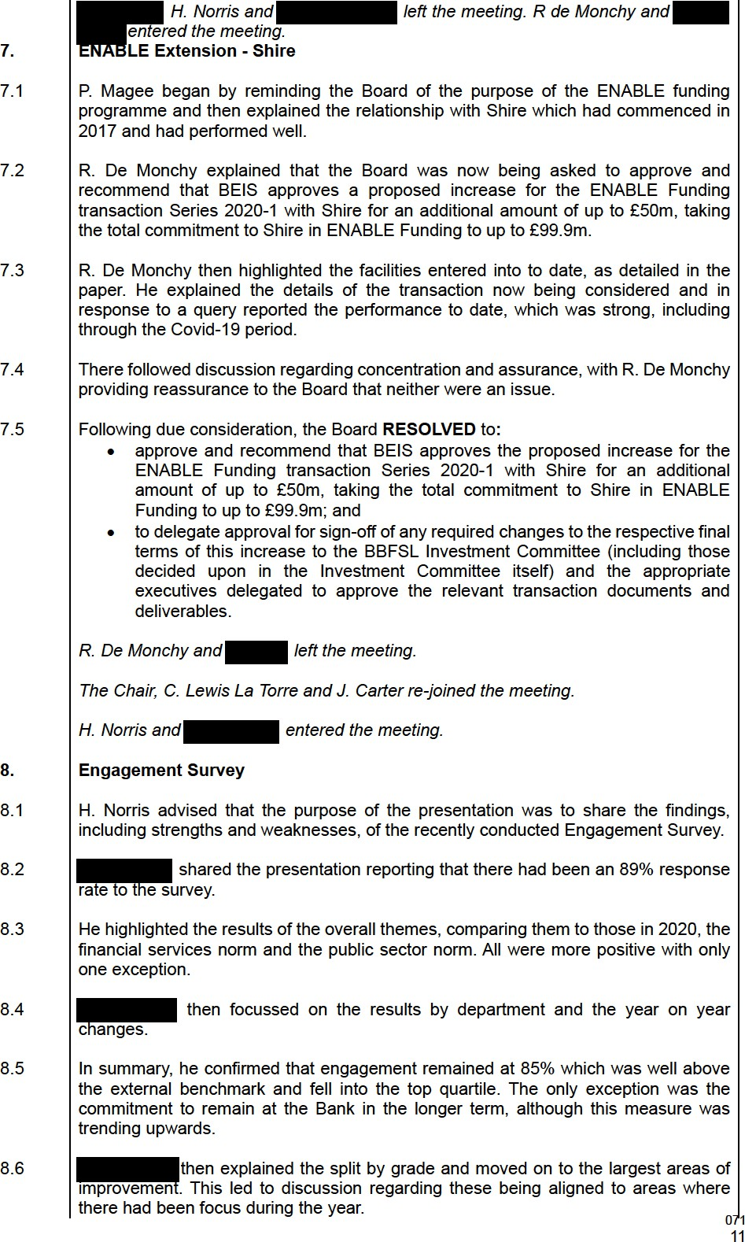
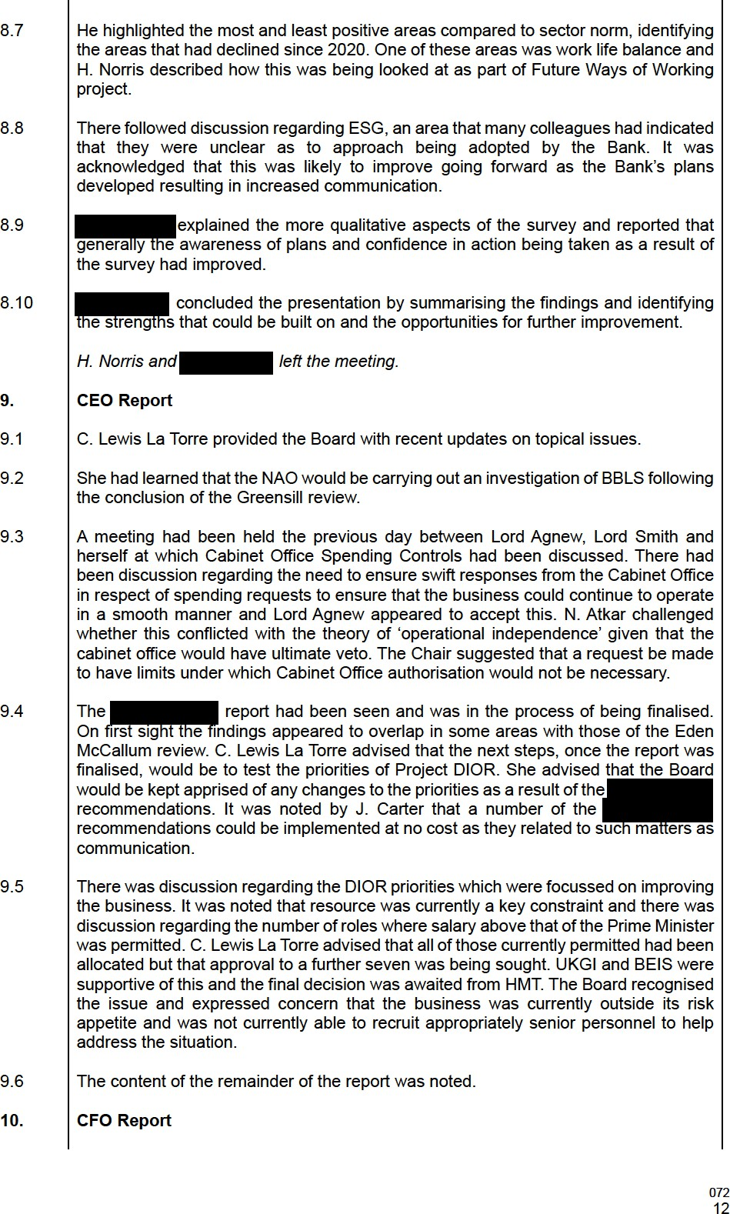
  - P. Piers began by reporting a strong March with five new commitments totalling £200m across the BBI, BPC and ECF portfolios. This resulted in a final full year position of
£882m, 10% short of budget of £870.6m.

  - The pipeline for the 2021/22 year remained strong and there was £100m commitments to date. It was reported that consideration was being given to available headroom within BPC and BBI.

  - P. Piers then moved to drawdowns advising that whilst ECF, BPC and GWS drawdowns tracked to budget, BBI had closed the year with an adverse variance of
£126m due to Invoice Finance lenders within the IP programme utilising revolving credit lines during the Covid-19 period. This would have a negative impact on stock numbers.
  - Moving on to Fair Value movements and ECLs, P. Piers reported positive movement of £119.7m against full year plan of a loss of (£24.7m). The most significant increases had been seen within BPC. There had been some impairments in the retail sector, but these had been less than expected.

  - SUL and Regional funds had also generally seen a strong year.

  - P. Piers advised that there were no issues relating to HMG accounting in respect of financial transactions or RDEL.

  - BAU costs, excluding Covid-19, were £3m below budget. This was predominantly due to OpEx costs being underbudget as an indirect result of Covid-19 with projects and events being delayed or cancelled. In addition, Staff costs were below budget due to a combination of transferring out costs associated with staff working on Covid-19 interventions together with slower than budgeted onboarding. Headcount has increased in Q4 but slower than budgeted with some roles now starting in FY 21/22.

  - P. Piers then moved on to KPIs. He reminded the Board that quantitative targets had been set for KPIs 1,2,3,4 and 6 and reported the following performance:
    - KPI 1 Stock: At Risk; the March 2021 stock estimate was £8.3bn, c.£811m behind the FY target of £9.1bn. BBI was c.£594m behind budget largely driven by unexpected distributions in the year, leading to a reduction in estimated stock in the month of March. In GWS, ENABLE Guarantees were also behind the revised budget. This estimate was based on FY net drawdowns and December leverage factors; however, it was unlikely that any changes in leverage would be sufficient to close the gap to Budget.

    - KPI 2 Diversity: On Target; the March 2021 estimated diversity of 94.2% remained ahead of the Budget of 94.0%. Outperformance followed on from relative stock weakness (vs budget) being weighted towards the guarantee programmes, which delivered through the Big 5 banks.
    - KPI 3 Regionality: At Risk; at March 2021 there was an estimated deployment of £881m outside of London vs the FY Budget of £880m. Strong regional performance in BBI and VS was helping to offset general Covid-19 driven weakness in GWS. Regionality of Q4 deployment could not be confirmed until full year stock was reported, but as it is coming in very close to Target, to be prudent, the KPI is marked as 'At Risk' while final numbers were awaited.
    - KPI 4 Encourage and Enable: On Target; the most recent quarterly SME Finance Monitor from December 2020 (March 2021 results were expected end of May) results were 27% for Awareness against a Target of 25%; the results of the annual Business Finance Survey in November 2020 were 41% for Consideration against a Target of 42% (survey confidence interval +/1.5pp).
    - KPI 6 Adjusted return: On Target; the March 2021 actuals of 6.7% compared to
a FY Budget of 0.1%. Return outperformance was driven by strong FV gains073
with a YTD gain of £110m compared to a FY Budget loss of £ (25)m, of which
£92m related to Q3. BPC had seen substantial positive valuation moves (+£84m YTD vs FY Budget -£(2)m) and BBI’s positive valuation movement of £26m YTD compared to a FY Budget £(23)m. Q4 revaluations were awaited (FV and ECLs) before this figure could be finalised, but it was very unlikely that the FY Target would be missed.
  - P. Piers then highlighted the costs associated to Covid-19 as detailed in the paper.

  - Moving onto other financial matters P. Piers highlighted:
    - Sign-off of the 2021/22 Business Plan by BEIS and HMT was awaited,
    - Assurance from the BEIS Permanent Secretary had been received that the estimated £12m costs of delivery of the Recovery Loan Scheme would be met by BEIS,
    - As previously explained, the business continued to work with the Cabinet Office in respect of Cabinet Office Controls which it was expected would be introduced in the Autumn. It was confirmed that spend and decision timelines would be tracked.
  - Details of the Financial Framework and the introduction of a Valuations Committee were noted.

CRO Report

  - E. O’Hara advised that he would assume that the paper had been read by Board members and highlighted the following matters:
Greensill Capital
  - There had been a Board call earlier in the morning at which the matter of Greensill Capital and the increased reputational risk and associated legal risk had been discussed at length.

Internal Audit Report on Delivery Partner Onboarding
  - This matter had been discussed in detail at the Audit Committee meeting the previous day including the actions to address the gaps highlighted.

Risk Appetite
  - E. O’Hara highlighted the prolonged period that the Bank had been operating outside its risk appetite and the potential long pathway to green. He reminded the Board that it was outside risk appetite on seven of the eight risk 1 categories. He explained that there was concern regarding the long-term impact on risk culture with a danger of ‘red’ becoming normal. This could potentially lead to control failures, financial losses as well as reputational damage.

  - It was noted that project DIOR was critical to the path to green. A funding and resourcing plan had been developed but this had not yet received Shareholder approval and there was therefore a risk that it would not be implemented to the standard needed. Furthermore, the implementation would, in any event, take some time.
Corporate Stretch
  - E. O’Hara went on to highlight the continued corporate stretch across the organisation as ‘right sizing’ was addressed whilst still delivering against revised Objectives and balancing limited resources. This led to a question regarding the ambitions of the Bank going forward and whether it was in danger of further overstretching itself.

  - N. Atkar felt there was a need for further clarity on the path to green in the context of whether action was being taken quickly enough and considering if anything further could be done to ease the problem. It was acknowledged that this would potentially involve considering whether some activities that added complexity should be halted.
  - C. Lewis La Torre responded by advising on the actions that were being taken through project DIOR and those that were being taken at an executive level. She also advised that there would be benefit in looking at the structure of the Bank as well as the operational model as there may be opportunities to simplify this and gain efficiencies.

  - ​
It was agreed that this would be a matter for consideration at the Board Strategy Day to be held prior to the July Board meeting. The Board requested that details of plans, priorities and timelines be prepared.

CLLT

It was agreed that C. Lewis La Torre would discuss the purpose and content of the Strategy Day with the Chair outside the meeting.

CLLT
  - There followed discussion regarding the different levels of risk across different areas of the Bank. Furthermore, it was acknowledged that the Bank had strong foundations but that issues had arisen due to the pace of growth. Furthermore, it was acknowledged that funding was the current major obstacle to significant improvement, albeit steps were continuously being taken to mitigate risks where possible.

Risk Appetite Policy and Risk Appetite Statement
  - E. O’Hara explained that the Board was being asked to approve the Risk Appetite Policy and Risk Appetite Statement for 2021/22.
  - He reminded the Board that the matter had been considered by the Risk Committee at its meeting in March when “it was AGREED that, given the mandatory nature of the programmes that gave rise to those credit and fraud risks, they should not be reflected in the Bank’s risk appetite, not least because it was the shareholder who bore those risks. However, as the administrator of the schemes, the Bank was responsible for administering the schemes well, so it was appropriate that the operational risks should be reflected in the Bank’s risk appetite. The Committee’s preference was to reflect risks from the COVID schemes in separate boxes, alongside the BAU risk appetite. It was noted that the document would be updated to reflect this change and be brought back to the Committee”.

  - These matters had been addressed and following due consideration and noting the recommendations of the Risk Committee the Board RESOLVED to approve the Risk Appetite Policy and Statement as presented.

S. Amarasekara, K. Cooper and entered the meeting.

Future Fund Deep-Dive

  - It was agreed that due to time limitations further information would be provided on Future Fund at the Board meeting scheduled to take place in July. In the meantime, K. Cooper highlighted the key points.

  - The final portfolio consisted of 1,191 companies with loans issued of £1.14bn. To date 85 companies had converted to equity at a value of £85m. There had been three insolvencies, one cancellation and one sale.
  - In response to a query it was agreed that fraud would be covered in more detail at the next meeting.

S. Amarasekara and left the meeting.

Future Fund: Breakthrough
  - J. Hartley explained that the purpose of the paper was to update the Board on the latest developments on Future Fund: Breakthrough (‘FFB), to seek agreement in principle to the launch of the scheme on 8th July and to seek in principle changes to the membership and processes of the Investment Committee for FFB and core BPC co-investment proposals.
075

  - She reminded the Board of the background to FFB which was a £375m fund announced by the Chancellor of Exchequer during the March 2021 Budget. It was intended to be an equity co-investment programme aimed at increasing funding for R&D intensive high growth companies in the UK operating on a fully commercial basis. This aligned closely to British Patient Capital’s existing co-investment programme, which was being rolled out during FY 21/22. HMT/BEIS had therefore agreed that FFB should also be delivered by BPC.
  - J. Hartley explained that the scheme was likely to be low volume/ high value and explained the process for its design including the strong challenge and resulting adjustments that had been made. She reported that the Board of BPC had agreed the launch in principle, subject to the provision of a pre-launch report in early June to confirm all outstanding matters.

  - BEIS and HMT officials were in the process of submitting updated papers to Ministers. The submission to the Chancellor of the Exchequer was expected to include a request for approval to launch (including launch date and launch comms).
  - J. Hartley then referred to Investment Committee governance, explaining the desire to strengthen the expertise for FFB and co-investments which would require an amendment to the Terms of Reference (‘TOR’). Accordingly, the BPC Board had agreed that a panel of 4-6 external investment experts (with investment expertise in the fields of deep-tech and life sciences) should be appointed as paid members of BPC’s Investment Committee for direct investing only (i.e. FFB and Core BPC co- investment activity), with minimum 2 external experts to be available to attend each IC meeting. Furthermore, these external experts would be members of the IC rather than advisors. It was envisaged that in addition, the existing IC membership would remain. As an interim measure it was proposed that R. Cummings and H. Moore would act as experts until the new panel had been appointed.

  - There followed several questions which were answered by J. Hartley. These related to diversity and levelling up as well as the testing of processes and systems.
  - There was discussion regarding the resourcing of the programme until such time as the recruitment had been completed with J. Hartley explaining that several projects including ESG piloting and FCA registration would be suspended in order that the existing team could be refocussed in the short term.
  - There followed discussion regarding the need for a detailed proposal for new product lines which would include demonstration of capability, processing, controls etc. K. Cooper advised that this information had been presented to the Product Development Group but had been summarised for the purposes of the Board paper. It was therefore suggested that a substantive audit trail of decisions be presented to the Board.

  - It was noted that whilst the intention was to announce the launch of the scheme in June, it was unlikely that the first investment would be made immediately, thereby allowing additional time to address the outstanding matters.
  - Following due consideration, the Board RESOLVED to approve in principle the launch of FFB and changes to the Investment Committee subject to:
    - Further consideration being given to Investment Committee membership, and
    - Reassurance being provided to the Board in respect of resource, capability, JH controls and processes, which were to be signed off by the relevant business heads.

Life Sciences Investment Programme

  - ​
J. Hartley began by reminding the Board that the proposal for a £200m fund dedicated to later stage life sciences was initially announced in 2020 budget and the business case was approved by BEIS in summer 2020. However, as a result of focus on Covid-
076
19 response schemes as well as some suggestions for changes in how LSIP would operate led to a delay in launch.

  - In addition, in late 2020, a new government department, the Office for Investment, was established and it became apparent shortly thereafter that a ‘Strategic Investment Partnership’, to potentially include UK life sciences, was being negotiated by the UK and UAE governments (via its Sovereign Wealth Fund, Mubadala). This latest development led to a further delay in the potential launch of LSIP, as the Chancellor decided LSIP would be a key vehicle for implementation of any future coordination in life sciences investment activity between HMG and UAE.
  - J. Hartley explained that negotiations with Mubadala were now at an advanced stage. All legal documents and the RFP had been prepared and the intention was to launch the scheme on 7 July.

  - Following due consideration, the Board RESOLVED to approve in principle the launch of LSIP, subject to reassurance being provided to the Board in respect of resource, capability, controls and processes, which were to be signed off by the relevant business heads.

NSSIF Update
  - The content of the paper which provided the Board with an update on the NSSIF programme and outlined the proposed direction of travel for the scheme was noted.

  - The Board requested that an additional paper, providing a strategic overview of the PM
scheme be prepared for discussion at the next meeting.

Any Other Business

BBFSL Power of Attorney
  - The Board agreed that Elizabeth O’Neill be added as an ‘A’ signatory to the BBFSL Power of Attorney.
  - There being no further business the meeting ended.
British Business Bank plc Company Number: 08616013 BPC Limited Company Number: 11271076
BBI Limited Company Number: 90901930 (‘the Company’ or ‘BBB’ or ‘the Bank’)
Minutes of a meeting of the Board of Directors of the Company Held at 8 Salisbury Square, London, EC4Y 8AP
and

VIA MICROSOFT TEAMS

At 9.00 am on Thursday 15 July 2021
Present: Lord Smith of Kelvin Chair BBB plc Neeta Atkar Senior Independent Director BBB plc
Jonathan Britton Non-Executive Director BBB plc
Jamie Carter Non-Executive Director (Shareholder Representative)
BBB plc
Jenny Knott Non-Executive Director BBB plc
Catherine Lewis La Torre BBB Chief Executive Officer BBB plc, BBI and BPC Ltd
Piers Linney Non-Executive Director BBB plc
Patrick Magee Chief Commercial Officer BBB plc
Dharmash Mistry Non-Executive Director BBB plc
Phil Piers Chief Financial Officer BBB plc
Amanda Rendle Non-Executive Director BBB plc
Nathaniel Sloane Non-Executive Director BBB plc
Russ Cummings BPC Chair BPC Ltd
Hazel Moore Non-Executive Director (BPC) BPC Ltd
Frances Small BBI Chair BBI Ltd
Sara Halbard Non-Executive (BBI) BBI Ltd
Judith Hartley BPC and BBI Chief Executive Officer BPC and BBI Ltd

In attendance
Elizabeth O’Neill General Counsel and Company Secretary Edward O’Hara Chief Risk Officer
(Item 10) Shanika Amarasekara Chief Impact Officer (Item 13)
(Item 13)
Reinald de Monchy MD, GWS (Item 14)
Paddy Lye Chief Operating Officer (Item 15)

- Notice, Quorum and Declarations of Interest and Introduction

Action

  - Proper notice having been given and a quorum being present, the Chair convened the meeting.

- Minutes

  - The minutes of the meeting held on 19 May 2021 were approved.

- Action Points/Matters Arising

  - It was noted that all actions had been completed or were scheduled to be discussed during the meeting.

- Chair’s Update

078
  - The Chair reported that recruitment for NEDs due to retire later in the summer was underway with some interviews having taken place. He advised that a further update would be provided as the matter developed.

- Board Committee Updates

Risk Committee
  - N. Atkar advised that a meeting of the Risk Committee had taken place on 10 June. The main considerations at the meeting included:
    - Presentation of the risk report which had included a recalibration and continued to reflect that risk was outside appetite. This had led to some discussion regarding the interpretation of ‘outside risk appetite’ by some HMG stakeholders and it had been concluded that there was a need to provide examples in order to improve understanding,
    - There had been discussion regarding the building of risk management capability with focus on risk strategy, the risk management framework and the risk management workstream in Project DIOR. The limited resource and budget were noted, and it was recognised that there was therefore a need to ensure there was no duplication across the areas and to focus on priorities.
    - There was discussion regarding the path to green,
    - The AMLRO report had been presented and discussed in detail and given the focus was now being applied to the fraud and money laundering risks with the Future Fund, the Committee asked the Head of Portfolio Operations and the Fraud and Financial Crime Director to attend and provide an update the next Committee meeting,
    - There had been a presentation from the CPO during which resourcing, leavers, pipeline applicants and talent management and culture had been discussed,
    - R. de Monchy had presented the delivery partner monitoring framework and whilst the framework was deemed to be appropriate, further clarity around timing was requested,
    - The Business Continuity Policy had been approved.

Audit Committee
  - J. Knott advised that the Audit Committee had met on 21 June. She advised that the main focus had been on Future Fund and Loan scheme valuations in preparation for submission to BEIS and Annual Report and Accounts. In addition, the life cycle of CLNs had been discussed. She explained that the training sessions that had been held for NEDs had assisted by way of preparation.

  - She further advised that changes to the ECL model had been discussed and agreed.

  - The Chair noted that this was the last Board and Audit Committee that J. Britton would attend as he was due to retire as a NED of the Bank with effect from 27 July 2021. He thanks J. Britton for his service and contribution to the Bank over that last seven years and wished him well for the future.

- CEO Report

  - C. Lewis La Torre advised that she was taking the report as read and added that some of the matters raised had been superseded by discussions held the previous day at the Board Strategy Day. She then highlighted the following matters:

  - The 2021/22 Business Plan had been agreed by both BEIS and HMT which had given certainty regarding funding.

  - The NAO investigation report on Greensill had been published. The PAC was due to be held the following week and C. Lewis La Torre would provide an update to Board members in due course. It was noted that the outcome had generally been positive but there were also lessons to be learned.

  - C. Lewis La Torre reported that there was an emerging risk around the State Aid temporary framework. It was too early to provide any detail at this stage, but an update would be provided following further investigation.

  - Latest information suggested that the Spending Review was likely to be a multi-year event and the process was likely to commence the following week. The Board would be kept informed as the bids were developed.

  - Referring to Project DIOR, C. Lewis La Torre advised that it had been discussed the previous day. She reminded the Board that the governance framework had been approved and established and that budgets were in place. She reported that project interdependencies were being managed by the Programme Board whilst interdependencies across the Bank more generally were being managed by the Executive Team.

  - She advised that the request for additional salary slots above that of the Prime Minister had been approved by BEIS and Secretary of State approval was now awaited. If approved at this level, the next stage would be to submit the request to CST. In the meantime, following the discussion with the Secretary of State the previous day, it was the intention of C. Lewis La Torre and A. Rendle to write to the Secretary of State highlighting the critical issues currently facing the Bank in respect of resource.

  - Referring to COP 26 and ESG, C. Lewis La Torre advised that a paper would be presented to
the Board at its meeting in September which would include a six-point climate strategy plan. SA

  - C. Lewis La Torre reminded the Board that the Recovery Loan Scheme (‘RLS’) had launched on 6 April 2021. P. Magee reported that take-up had been lower that expected with £129m of offers having been made to date. He advised that initial analysis suggested that the large Banks were not utilising the facility and explained the surmised reasons why this was the case, including that there were currently no issues in obtaining credit elsewhere. He did however advise that there was still market appetite. In addition, early discussions had commenced with BEIS and HMT in respect of a potential successor scheme and the role it could play in satisfying unmet demand. The Board would be kept updated of developments.

  - C. Lewis La Torre advised that two new schemes had launched, Future Fund: Breakthrough and the Life Sciences Investment Programme (‘LSIP’). J. Hartley was to provide further detail later in the meeting.

  - R. Cummings added that he felt the launch of LSIP would become a strategically important milestone in the future of the Bank and thanked C. Lewis La Torre and J. Hartley for their contribution in ensuring that that the Bank retained the mandate to manage the programme following discussions the previous year. He added that it would be an important stepping-stone for the Bank in managing third party funds and was an indication of the role that BBI and BPC could play in the Bank’s future.

  - C. Lewis La Torre concluded by advising that the analysis of the final Covid-19 loan schemes had been released the previous week. This showed that £79.3bn loans had been provided to
1.76m businesses. The regional split of the data was noted. It was further noted that the balance sheet of the Bank would begin to reduce once loans were repaid and the Board would be kept informed.

- CFO Report

  - P. Piers began by reiterating that the 2021/22 Business Plan had been approved by HMT which brought more certainty around funding. He reported that OPEX and staff costs had been split into three separate pots which were not fungible:
    - Pre-Covid programmes £82.7m,
    - Covid Schemes (including DIOR £8.6m but excluding RLS) £50.5m; and
    - RLS £9.3m. Note: HMT have only approved RLS funding of £5.7m but BEIS have committed to fund any additional costs above £5.7m up to £9.3m.

  - He added that RLS had not been fully funded but that BEIS had committed to make-up any shortfall.

  - P. Piers then moved on to the HMT and BEIS savings and efficiency exercises. He reported that HMT had commissioned an efficiency saving of 5% across the whole of HMG. The Bank had committed to an additional £2m saving by 2024/25 compared to the original Business Plan.

  - A second savings and efficiency exercise had also been commissioned by BEIS, looking at the options available to deliver FT and RDEL savings of 15% and 25% between 21/22 and 24/25. The approved 21/22 Business Plan already delivered the requested levels of FT savings by 24/25 so the Bank was not proposing any further amendments. There was also significant RDEL savings built into the 21/22 Business Plan but in order to meet the 25% target, further RDEL reductions of £7m would be required. It was the view that further RDEL cost savings by080
taking a % reduction across all areas within BBB would adversely impact our control environment. It was therefore proposed instead that the £7m net RDEL reduction could be achieved by investing further in BBI debt programmes which would generate sufficient RDEL income to meet the net target whilst remaining within budget for FT. The Bank had also looked at savings that could be achieved by terminating individual programmes and a full list of programmes costs, and assumed savings by 24/25, had been provided to BEIS together with the impact of doing so on HMG policy objectives and BBBs objectives.

  - Referring to staff resource, P. Piers advised that pending further discussion the action to convert the remaining fixed term contractors had been paused to allow flexibility as to where the heads should be deployed.

  - Moving on to day rate contractors, he explained the rationale for the original recruitment and advised that, given the cost of such colleagues, the intention was to reduce the number as far as possible.

  - P. Piers explained that the 2020 BEIS/HMT review of the Bank’s financial framework had concluded that it should be reformed. The original intention had been to move to full AME but it had been concluded that this would not be the best solution. A number of less dramatic changes were however being made.

  - P. Piers advised that the Bank was likely to become subject to Cabinet Office Spend Controls in the Autumn. The contracts affected were noted.

  - P. Piers reported that the Board was being asked to approve forecast payments totalling £6.7m (total cost £9.445m) to KPMG in relation to the CBILS operational audits over the contract term and to approve forecast payments totalling £5.0m (total cost £7.181m) to RSM in relation to audit assurance services for the Covid-19 schemes over the contract term.

  - He explained the background, that the increase fell within budget, the benefits of the service. He confirmed the procurement process and following due consideration, the Board agreed to APPROVE the changes as proposed.

  - The financial performance of the Bank to 31 May 2021 was noted. He did however advise that the performance of the Bank’s Covid response schemes were not included as not all data had been received. He advised that it was too early to accurately forecast 2021/22 though the estimates detailed in the paper were noted.

  - P. Piers detailed the key performance drivers being commitments, drawdowns and distributions, fair value and ECLs as included in the paper.

  - He reported the performance of Start-Up Loans advising of 999 new loans in May. This led to discussion regarding the contribution of SUL to the diversity and regionality KPI. It was agreed that consideration should be given to more detailed internal analysis of the KPI but noted that given the practical challenges the KPI itself should be kept simple.

  - P. Piers noted that there were no issues to report around HMG accounting. Furthermore, there were no issues around costs, but P. Piers advised that a reforecasting exercise was scheduled
to improve the phasing of costs. It was agreed that P. Piers would bring a more holistic view of PP
costs to the next meeting along with visual information.

- CRO Report

  - The content of the report was noted.

  - E. O’Hara drew attention to reputational risk where concerns had increased since the last meeting resulting in the risk profile moving further away from risk appetite. This was predominantly due to the range of impending potentially challenging reports/investigation outputs that were expected to have significant media attention. The particular reports he drew attention to were:
    - Continued media attention on Greensill Capital,
    - NAO investigation into Greensill Capital and report publication,
    - NAO phase 2 investigation into BBLS being underway,
    - Publication of Covid debt and equity response scheme analytics,
    - Fraud analysis on BBLS, though not expected to be published in BEIS accounts until October, and
    - Some challenging discussions with government stakeholders following the delayed launch of the Future Fund Breakthrough programme.

  - He reported an increase in legal and compliance risk due to Greensill and emerging State Aid risks. In response to a query, he explained the circumstances surrounding the State Aid risk, advising that further investigation, in conjunction with BEIS legal department, was underway.

There followed discussion regarding some minor breaches by smaller delivery partners relating to the Covid-19 loan schemes. E. O’Neill explained that a framework had been developed to ensure that these were dealt with on a consistent basis. She confirmed that this framework took account of the comments contained in the NAO report on Greensill.

This led to discussion regarding due diligence and E. O’Hara explained that the process had been enhanced for RLS which had been possible as the programme was not being delivered at the same pace as the original Covid-19 programmes. He added that the audit assurance process was enabling issues to be identified and addressed.
  - J. Carter challenged whether the reputational risk was being conflated given that the NAO report had now been issued and had generally been well received. E. O’Hara acknowledged that the risk had possibly decreased in the short term but felt the risk would continue to be outside appetite for some time to come. This led to discussion regarding the measurement of reputation risk and it was noted that this would be considered as part of a bigger review of risk appetite.

E. O’Hara next highlighted ongoing concerns relating to fraud and financial crime. He reported that the team was currently stretched and as a result prioritisation was taking place, which included developing relationships with delivery partners to ensure that appropriate controls were in place. P. Magee advised that recruitment for risk resource into GWS was being considered. C. Lewis La Torre explained the reasons for the delay in agreeing additional resource which included the need to reassess and prioritise across all areas of the Bank. J. Knott stressed the need to focus on this area and requested that the Risk and Audit Committee be kept updated of developments.

EO’H

  - E. O’Hara concluded his report by providing an update on the progress being made on the schemes claim process and the internal audit.

- Commercial Arm Update

  - The content of the report, providing an update on the main strategic and operational matters within the commercial division was noted.

  - J. Hartley highlighted the financial performance to end March 2021. She reported new commitments of £772m across 30 transactions which was the highest in volume in the history of the commercial arm. This resulted in total investments of £4.3bn across 125 investments with 33k SMEs benefitting.

  - She reported that notional returns were estimated to be £320m, which again was a record, split as follows:
    - BBI: £120m split £50m actual and £70m fair value uplifts, and
    - BPC: £200m split £15m actual and £185m fair value uplifts.

  - It was noted that these numbers aligned to market trends and that the values within BPC were highly concentrated.

BBI
  - J. Hartley advised that the end-to-end investment process within BBI had been reviewed and a new process was being implemented and the team structure was being reviewed to increase efficiencies.

  - J. Hartley next drew attention to the capital position of BBI. She explained that there were currently constraints given the size of the programme compared to the opportunities available. She explained that consideration was therefore being given to alternative sources of capital. It
was agreed that following discussions at the Board Strategy Day the position would be reviewed further in September.

  - J. Hartley then explained that other areas of focus within BBI related to its contribution to net zero and the regional agendas.  added that he felt that BBI investments had moved from ‘problem fixing’ to enabling sustainable growth.

  - There followed further discussion regarding the need for additional capital being fundamental to the future of BBI. C. Lewis La Torre added that consideration would be given to providing additional capital if it was concluded that this was strategically appropriate.

BPC
  - J. Hartley reported that the Future Fund: Breakthrough programme was due to be launched on 20th July and the Life Sciences investment Programme had been launched on 7th July with a Memorandum of Understanding, including a framework outlining principles of the collaboration, being signed with Mubadala on 28th June. In line with the Strategic Investment Partnership signed by Mubadala/HMG in March, Mubadala will invest £800m into UK Life Sciences, some of this to be alongside LSIP’s £200m.

  - She advised that a new Investment Committee for direct investments, principally these two programmes, was in the process of being formed. It was the intention that independent advisors would participate on the Committee and discussions with potential advisors had commenced.
R. Cummings thanked D. Mistry and H. Moore for their assistance in identifying potential high calibre candidates.

  - The Terms of Reference for the new Committee were in the process of being finalised.

  - J. Hartley reported that the search for a new Managing Director for BPC was ongoing. To date the business had not been successful due to the salary constraints.

  - Moving onto FCA authorisation, J. Hartley advised that the discovery stage reports had been recently been received. In summary, the reports concluded that subject to a number of matters being addressed, BPC was suitable for registration. This led to extensive discussion regarding the process of registration with some debate regarding the effort involved. It was nonetheless agreed that an update would be provided once a full analysis of the discovery reports had been concluded.

  - J. Hartley went on to report that there had, the previous day, been discussions with C. Roxburgh of HMT regarding the role BPC could potentially play in DC pension fund ambitions. This was a developing area and further updates would be provided.

  - C. Lewis La Torre highlighted the various options that may be suitable, explaining the merits or otherwise of each. This led to discussion regarding the strategy of BPC and the commercial arm generally, including capital raising, leverage etc. It was noted that this would be considered further by each of the Boards in September.

  - Finally, J. Hartley advised that the ongoing issue of a BPC incentivisation plan was to be discussed by the Remuneration Committee later in the day.

entered the meeting.

- NSSIF Strategic Overview

  - P. Magee began, referring to the previously circulated paper, by explaining that NSSIF had been well received across HMG and highlighting that there were currently seven NSSIF accredited fund managers with an investment commitment totalling £94m. He added that there was additional resource of £80m to commit in the current financial year via BPC and ECF.

  - He advised that in light of the progress, and as part of the activities with HMG to update and evolve NSSIF’s governance, NSSIF’s strategic oversight body (“NSAB”), which BBB had always attended, was being reformatted to an “NSSIF Board”, with new terms of reference. P. Magee had been asked to participate as co-Chair of this strategic-level programme board.

  - P. Magee advised that the core responsibilities for key elements of the NSSIF programme would remain as defined in the original MoU, which would remain in place, with the
responsibility of the relevant contributing parties remaining unchanged, including those of the accounting officer. He went on to explain the implications of the changes on BBB as detailed in the paper.

  - N. Atkar queried the purpose of BBB participating on the Board and how conflicts would be managed.  explained that the Terms of Reference allowed for P. Magee to recuse himself should any conflicts arise.  then went on to explain the perceived benefits of BBB participating on the Board. E. O’Neill opined that participation would result in BBB being strategically involved which would bring additional risk. It was agreed that the matter would be
discussed offline with the Chair, N. Atkar, C. Lewis La Torre and P. Magee and a decision would PM
be made.

  - The content of the paper detailing NSSIF’s potential direction of travel was noted.

left the meeting.

- BPC/BBI Investment Committee Terms of Reference

  - E. O’Neill explained that the Boards of BBB plc were being asked to consider and if thought fit approve a recommended amendment to the BBI and BPC Investment Committee Terms of Reference quorum requirements.

  - She explained that the reason for the change was to enable any delegates of the CEO of BBI/BPC to be included for quorum purposes. As per the existing Terms of Reference, any such delegation by the CEO of BBI/BPC would require the approval of the Chair of the Investment Committee in advance of the meeting.

  - Following due consideration, the Board RESOLVED to approve the change as presented.

- Health & Safety Policy

  - The content of the paper and associated Health & Safety Policy was noted.

  - Following due consideration, the Board RESOLVED to approve the Health & Safety Policy as presented.

S. Amarasekara & entered the meeting.

- Future Fund Current Status

  -  began by reporting that all applications to Future Fund had been processed and that the final portfolio consisted of 1,190 companies with loans issued of £1.4bn.

  - As at June, 120 had converted to equity at a value of £139m. There had been seven insolvencies, two cancellations and three exits.

  - There followed discussion regarding the regionality of the portfolio, which was similar to market and diversity which was better than market.

  - reported that the team was in the process of updating the Fraud Risk Assessment and Financial Crime Risk Assessment. These are due for completion, along with the Post Event Assurance Plan (PEAP), by the end of August.

  - There followed discussion regarding the future of the portfolio and the intention was to prepare management options for HMG to consider, including options for follow-on/recycling.

  - The Board was supportive of the future steps and it was agreed that an update would be provided in due course.

S. Amarasekara and left the meeting. R. de Monchy entered the meeting.

- Programme Approvals

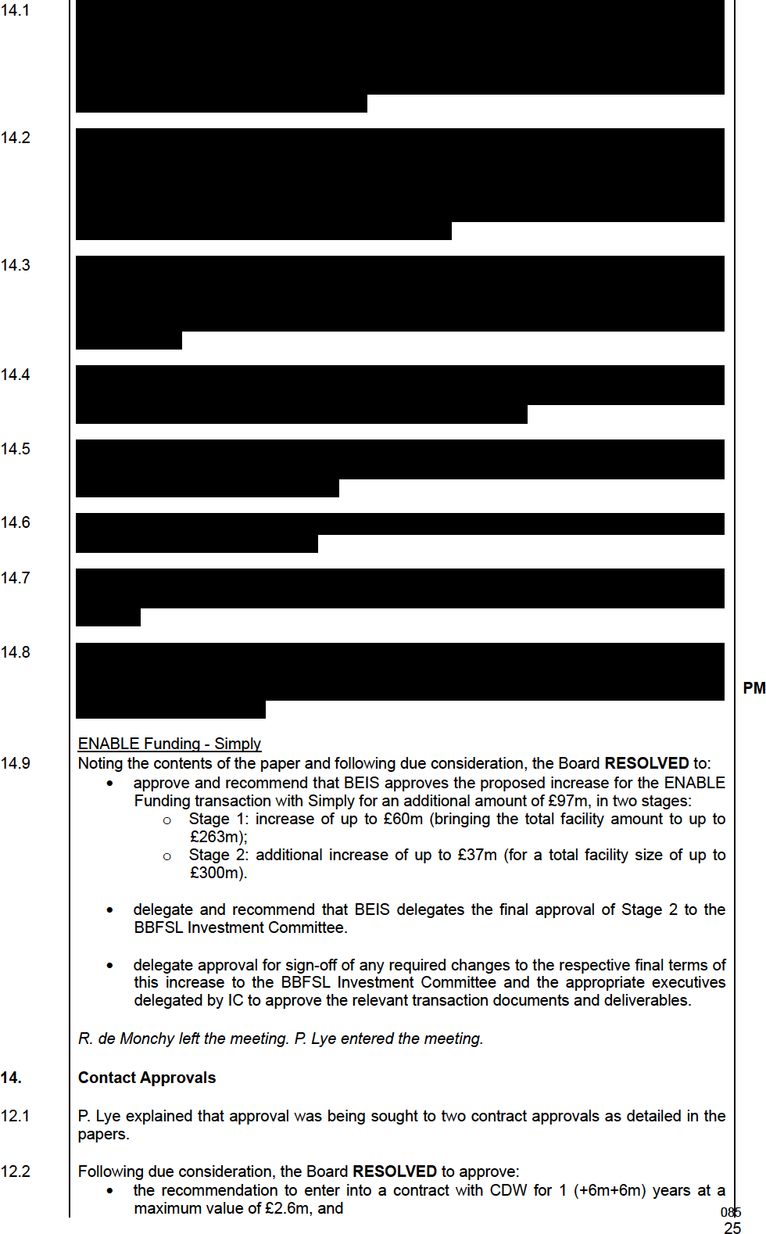
- the contract award and expected cost for ANS. (The length of the contract was set at two years with two periods of one-year extension available (2+1+1), which is the maximum term allowed under G: Cloud. The total value of the contract is estimated to be up to £2,004,365.00 (c500k per year).

- Any Other Business

  - There being no further business the meeting ended.
British Business Bank plc Company Number: 08616013 (‘the Company’ or ‘BBB’ or ‘the Bank’)
Minutes of a meeting of the Board of Directors of the Company VIA MICROSOFT TEAMS
At 9.00 am on Tuesday 3 August 2021
Present: Lord Smith of Kelvin Chair BBB plc Neeta Atkar Senior Independent Director BBB plc
Jamie Carter Non-Executive Director (Shareholder Representative)
BBB plc
Jenny Knott Non-Executive Director BBB plc
Catherine Lewis La Torre BBB Chief Executive Officer BBB plc
Patrick Magee Chief Commercial Officer BBB plc
Dharmash Mistry Non-Executive Director BBB plc
Amanda Rendle Non-Executive Director BBB plc
Nathaniel Sloane Non-Executive Director BBB plc
Phil Piers Chief Financial Officer BBB plc
Apologies Piers Linney Non-Executive Director BBB plc BBB plc
In attendance Elizabeth O’Neill General Counsel and Company Secretary Shanika Amarasekara Chief Impact Officer
Edward O’Hara Chief Risk Officer
Judith Hartley BPC and BBI Chief Executive Officer
Helen Norris Chief People Officer
Warren Ralls MD, UKN

Action
- Notice, Quorum and Declarations of Interest and Introduction
  - Proper notice having been given and a quorum being present, the Chair convened the meeting.

Corporate Performance Reports

A.Rendle began by advising that the purpose of the meeting was to determine the corporate performance of the Bank for the 2020/21 year to be used for the Performance Bonus Plan and the LTIP Cycle 5.
BBB Corporate Performance: 20/21 Performance Bonus Plan
  - P. Piers advised that he would provide a summary of the performance against qualitative and quantitative objectives to enable the Board to form a view on the annual Performance Bonus Plan. He would then cover performance for LTIP cycle 5.
  - He reminded the Board that whilst the main focus had been on delivery of the Covid- 19 programmes, a decision had been taken to retain the quantitative KPIs, solely focused on the BAU programmes for the purpose of 20/21 corporate performance assessment, albeit with the targets adjusted to reflect the impact of Covid on BAU programme delivery.

  - He highlighted and explained the range of awards payable as a percentage of bonus eligible salary.
  - P. Piers went on to report that the Bank had achieved or exceeded target on three and a half of its five quantitative KPIs and marginally missed target on one half. The underperformance on the remaining KPI was in part due to the continued impact of the pandemic.

  - He went on to advise that qualitative performance reports on its five qualitative KPIs in 20/21 had been detailed in the paper. As previously agreed, no opinion was offered on the qualitative KPI outcomes. The performance summaries provided within the main body of the paper along with the full qualitative performance reports in the appendix, which were intended to provide the Board with sufficient information to form an opinion, were noted and the following were highlighted.

  - W. Ralls and  went on to explain performance against objective 3, to identify and help to reduce regional imbalances in access to finance for smaller businesses across the UK. They covered:
    - The background, detailing how this was interrupted by Covid-19,
    - Activities undertaken to assist in addressing the issue,
    - The RepTrack survey output,
    - Shift in position from demand to supply led.
  - There was positive feedback on the progress made and the need to continue in strong way was acknowledged.

  - E. O’Hara then highlighted the progress made against objective 6, to achieve the Bank’s other objectives whilst managing taxpayers’ money efficiently within a robust risk management framework. He advised that the target was deemed to have been achieved and explained at how this conclusion had been arrived. He explained the survey that had been undertaken, the independent benchmarking of the Risk Management Framework.
  - Referring to the centre of expertise objective, J. Carter advised that it was informed by the UKGI report along with information from external surveys of the centre of expertise stakeholders both within and outside HMG.

  - He explained that with HMG, the delivery of the Covid-19 schemes was a major achievement. It was also felt that the position around the Life Sciences Investment Programme, particularly the negotiations with a third party, were a strong result which had increased the reputation of the Bank within Whitehall.

  - The only less positive comment had been around thought leadership, but J. Carter felt that this should be balanced across the remit of the Bank during the 12 months under consideration.

All executives left the meeting leaving only NEDs and the Deputy Company Secretary.
  - A.Rendle explained the process for determining the awards including that once the Board had given a steer, the matter would be considered by the Remuneration Committee which would then make a recommendation to the Board for approval. She was looking for the views of Board members on the overall performance.

  - There was extensive discussion with the Board unanimously agreeing that the performance was exceptionally strong during the year with any negatives being offset by the delivery of the Covid-19 schemes.
  - Each Non-Executive Director explained their rationale for arriving at this conclusion and it was noted that the views of those unable to attend were in line with the Board generally.

  - The Board AGREED that the award should fall into the ‘exceeded’ range and 85% was the general steer for Remuneration Committee.
088

It was agreed that going forward the targets and measurements should be reviewed to ensure that they drove the right behaviours to scale the organisation to become a best in class development bank.

- 2.16
Long Term Incentive Plan – Cycle 5
A. Rendle explained that the LTIP cycle 5 objectives were set three years ago, pre- pandemic, and as such it could questioned as to their relevance for assessing the executive team performance.
  - The various thresholds were noted along with the performance percentages applied in previous years.

  - There was lengthy discussion regarding the measurements and metrics and it was agreed that the LTIP review should be commenced as soon as possible to ensure that it was driving the appropriate outcomes going forward. In the meantime, the Non- Executive Directors focussed on the delivery of information, regional imbalance and centre of expertise.
  - It was AGREED that the Remuneration Committee should use its discretion to ensure that the performance factor for the Bonus Plan and LTIP should be the same or similar given the performance during the year.

Any Other Business

  - There being no further business the meeting ended.
British Business Bank plc Company Number: 08616013 (‘the Company’ or ‘BBB’ or ‘the Bank’)
Minutes of a meeting of the Board of Directors of the Company VIA MICROSOFT TEAMS
At 10.00 am on Tuesday 10 August 2021
Present: Lord Smith of Kelvin Chair BBB plc Neeta Atkar Senior Independent Director BBB plc
Jamie Carter Non-Executive Director (Shareholder Representative)
BBB plc
Jenny Knott Non-Executive Director BBB plc
Catherine Lewis La Torre BBB Chief Executive Officer BBB plc
Patrick Magee Chief Commercial Officer BBB plc
Amanda Rendle Non-Executive Director BBB plc

Apologies Piers Linney Non-Executive Director BBB plc
Dharmash Mistry Non-Executive Director BBB plc
Phil Piers Chief Financial Officer BBB plc
Nathaniel Sloane Non-Executive Director BBB plc BBB plc

In attendance

Edward O’Hara Chief Risk Officer
Judith Hartley BPC and BBI Chief Executive Officer
Helen Norris Chief People Officer (Item 2) (Item 2)
Shanika Amarasekara Chief Impact Officer (Item 3) Graeme Fisher MD, Strategy (Item 3)

Action
- Notice, Quorum and Declarations of Interest and Introduction

  - Proper notice having been given and a quorum being present, the Chair convened the meeting.

H. Norris and entered the meeting.

Corporate Performance Rewards

  - A. Rendle began by advising that following the meeting of the Board the previous week the Remuneration Committee had met to determine the recommended awards under the annual bonus plan and LTIP Cycle 5 which the Board was now being asked to approve.

BBB Corporate Performance: 20/21 Performance Bonus Plan
  - A Rendle reminded the Board that the annual bonus plan applied to bands 4-7. The Remuneration Committee had had a robust discussion and noting the guidance from the Board had agreed to recommend a performance factor of 85%

  - Following due consideration, the Board agreed to APPROVE the performance factor of 85% as recommended.
Long Term Incentive Plan – Cycle 5
  - A. Rendle advised that there had been discussion regarding the operation of the LTIP and reported that although the targets had been set three years prior, it was not an average of the previous three years but was based on performance for the year in question.

  - She advised that there had been lengthy discussion by the Remuneration Committee following which, it was agreed that a recommendation be made that a performance factor for LTIP cycle 5 be applied.
  - Following due consideration, the Board agreed to APPROVE the performance factor of 85% as recommended.

H. Norris and left the meeting. S. Amarasekara and G. Fisher entered the meeting

Spending Review

  - S. Amarasekara began by advising that the timeline for the submission of Spending Review bids was extremely tight with the first submission due to be submitted on Friday 13th August and the detailed submission by 27th August. She advised that the approach therefore had been to focus on the Spending Review bids whilst allowing room for discussions in due course regarding the strategic plan.
  - She shared a slide which demonstrated the timelines applicable to the four workstreams relating to planning.
Spending Review
  - S. Amarasekara explained the purpose of the Spending Review. She reported that whilst the timing for the conclusion of the process was uncertain the team were working towards the end of October.
  - J. Carter confirmed that this too was his understanding. He stressed the importance of the bids given that it was possible that no later top-ups would be forthcoming as had been the case in recent years. He added that this should not however be viewed as a blank canvas for the Bank and that the priorities of the Secretary of State should be carefully considered.

  - In response to a query J. Carter confirmed that it was currently the intention that this would be a three-year Spending Review but that this could change at the last minute. He did however confirm that this would not prevent continuous discussions with BEIS regarding the future strategy of the Bank.
Strategic Planning
  - S. Amarasekara advised that the Strategic Planning workstream was a continuation of the discussions that had taken place at the Board Strategy Day in July with a view of setting a strategy that would underpin the purpose of the Bank going forward.

  - She advised that a draft framework was being developed and the intention was to align the strategy with the objectives of the Secretary of State and wider Government. This was being considered as part of the Spending Review process and this would be one of the main focusses of the Board meeting in September.

Institutional Capital
  - S. Amarasekara advised that discussions were continuing with HMT over the summer and an event on this topic, with the PM and Chancellor, was being planned in the Autumn.

  - C. Lewis La Torre added that discussions to date had centred around the role BPC could play to catalyse UK pension plan investment in patient capital which could involve BPC as a platform or manager of investment mandates (for which FCA authorisation would be required) or the use of BPC assets to seed new investment products. There were multiple parties and initiatives involved in the wider project, initiated by HMT, which were being tracked by the Bank.

The Board would be kept updated of developments.

091
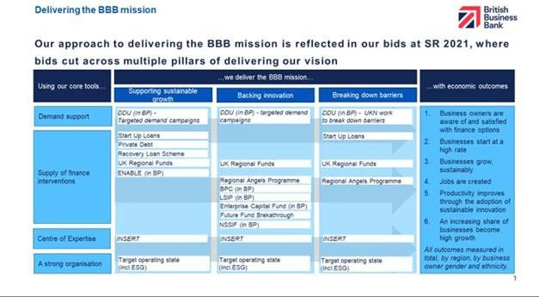
Business Plan
  - S. Amarasekara advised that it was the intention that the strategic planning would inform the 2022/23 Business Plan priorities. C. Lewis La Torre added that the Executive Team were also considering which products should be discontinued and an update would be provided to the Board at its meeting in September. In the meantime, the Spending Review was taking priority given the tight timelines.

  - In response to a query, S. Amarasekara shared a slide which contained the detail of the Spending Review process. She highlighted that once the initial bids had been submitted a period of negotiation was likely to follow and some scaling back was expected. Regardless of this expectation, she confirmed that the initial bids would be based on what could be delivered and some may include phasing over several years.
  - The timelines were explained in detail and S. Amarasekara stressed the need to be conscious of stakeholder sensitivities, including colleagues, throughout the process.
Spending Review Bids
  - S. Amarasekara then drew attention to the proposed Spending Review bids explaining that they reflected the approach to deliver the BBB mission and that bids cut across the multiple pillars of delivering funds. She referred to the slide below which detailed all bids:

  - She advised that the new area covered was UK Regional Funds explaining the rationale of the products and the way it was envisaged it would operate. C. Lewis La Torre added that such a product covered a fundamental area in which the Bank should be active as well as supporting the levelling up agenda. She did however note that reaching the devolved nations may be challenging.
  - S. Amarasekara went on to explain the bid around Start Up Loans which was based on a multi-year bid rather the annual arrangement that had been in place in recent years. This led to lengthy discussion regarding the need to push strongly on this bid given the economic benefits.

  - The potential extension to RLS was than discussed with P. Magee reporting that momentum on the current RLS scheme was good.
  - All other bids were noted by S. Amarasekara and she highlighted that the primary focus was to keep the existing business plan intact.
  - It was noted that there was a need to ensure that net zero was included as a consideration on a programme-by-programme basis and C. Lewis La Torre provided reassurance that the six-point plan that had been developed formed part of the considerations.

  - S. Amarasekara added that work was also commencing on an operational RDEL bid, the timelines for which were slightly longer.

  - N. Atkar raised a query regarding the Centre of Expertise objective and whether the thought leadership skills within the Bank could be used across HMG more generally, perhaps in areas where bids were unsuccessful and where the Board’s strategic ambitions were not in the short term in line with or a priority for wider HMG objectives. Feedback from year end surveys indicated that such thought leadership should be welcomed. J Carter agreed that this would be a way of influencing over time. C. Lewis La Torre confirmed that opportunities along these lines were already being considered.
  - There followed discussion regarding return targets and C. Lewis La Torre confirmed that work in this area had also commenced, advising that there would be a need to take a long-term view given the nature of some investments. In addition, she noted that regional programmes would be run on a commercial basis with a view to making a positive return.
  - J. Knott raised several queries including that outcomes be reviewed, including productivity.

  - Following due consideration that Board confirmed that it was content with the approach being adopted, subject to any final comments being fed back to S. Amarasekara in the next two days and a copy of the summary submission being loaded onto Diligent when ready

Any Other Business
  - There being no further business the meeting ended.
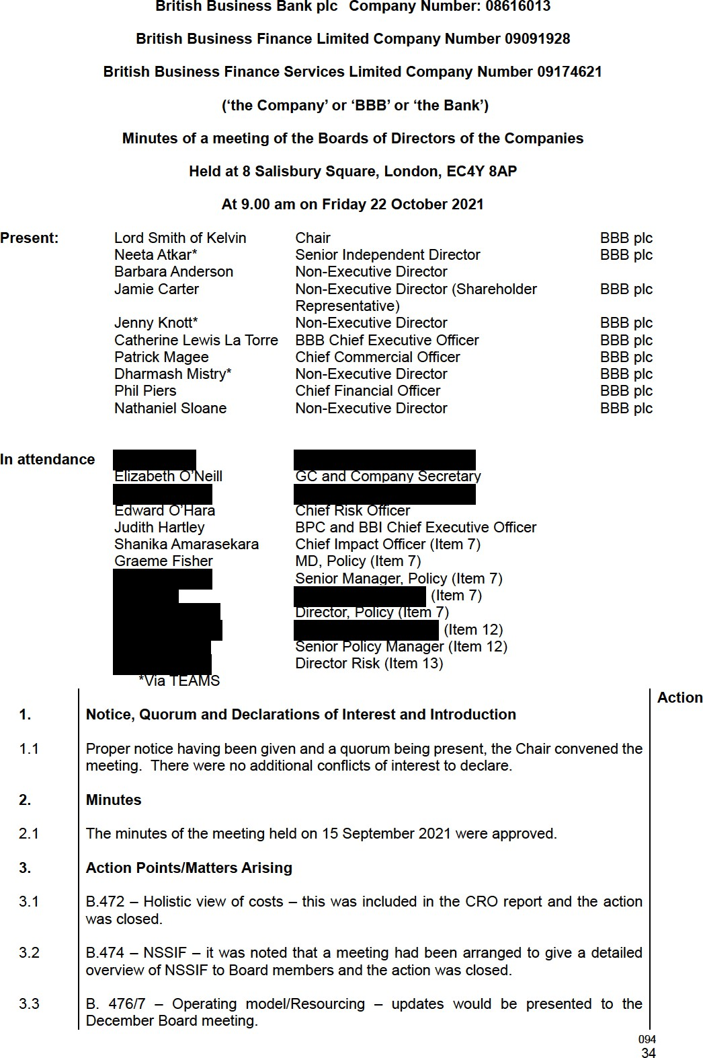

  - B.478/9 – Life Sciences Investment Programme/ BPC Strategy – updates would be provided later in the meeting and the actions were closed.
  - B.480 – Bank wide business strategy – S. Amarasekara had made arrangements to discuss outstanding items with D. Mistry and the action was closed.
  - B.481 – Concentration Risk – the matter was due to be presented to the Risk Committee at its meeting in November
  - B.482 – Powers of Attorney – E. O’Neill confirmed that parameters had been put in place under which C. Lewis La Torre could make changes to the managers named on the Powers of Attorney, as previously requested by the Board, and the action was closed.

  - B.483 – Terms of Reference Review – recommendations would be made to the Board at its meeting in December.

Chair’s Update

  - The Chair began by welcoming B. Anderson to the Board.
  - He advised that the Nominations Committee had completed an interview process for a Non-Executive Director to replace P. Linney and an update would be provided once the matter had been considered by the Secretary of State.

  - He advised that the Remuneration Committee had met the previous week to discuss the matter of the number of roles permitted that exceeded the Prime Ministers Salary. He explained that a recent change in the method of calculation had resulted in the Bank having more slots remaining available than previously and the Committee had therefore concluded that there was not a need to apply for more slots at the current time and the application should therefore be withdrawn. The Board confirmed that it was content with this decision.
  - He advised that the SUL Ambassadors event at which he had been scheduled to speak had been delayed until November and would now be a virtual event.

Committee Update
Audit Committee
  - J. Knott reported that the Audit Committee had met the previous day.

  - The Committee had agreed to recommend the BPC and BBI accounts for approval and they would be taken to the respective Boards on 10/11 November respectively. Positive feedback had been received from the NAO. She confirmed that the unrealised gains had been discussed and the uncertainty acknowledged.

  - It had been reported that a gap analysis of Functional Standards had been carried out as required by HMG and whilst the findings had been acceptable evidencing the position was onerous.
  - Three internal audit reports had been completed in the period, the findings of which were reasonable assurance. Further information had been requested in certain areas including people risk, Future fund early warning indicators and capability and capacity due diligence.
  - The numbers prepared for BEIS had been signed off.

  - It had been noted that R. Cummings would be attending a BEIS networking event on behalf of the Bank.

CEO Report

  - The content of the report was noted.

  - C. Lewis La Torre advised that the upcoming Spending Review had been a major focus of the Bank in the recent period and an update would be provided later in the meeting.
  - She advised that the initial report on the investigation into BBLS by the NAO had been received. The two main issues raised related to the speed of additional fraud prevention measures being applied and the increases in costs attributable to the scheme, due to it being extended and being larger than initially anticipated.
  - Work was ongoing to refine the wording in the report. It was noted that there would likely be a PAC hearing in January 2022.

  - It was noted that a milestone of £1bn had been reached by RLS and it was expected that the scheme would be extended. This would be discussed later in the meeting.

  - C. Lewis La Torre than drew attention to the section in her report pertaining to resourcing and operations. She advised that there was now more flexibility in recruitment at a senior level given the change of calculation of salaries above that of the Prime minister as discussed earlier in the meeting, although this would also depend on the funds available following the Spending Review.
  - She reported that the staff turnover rate had increased to 8.6% in September compared to 6% during the Covid period (12% prior to Covid). The key drivers appeared to be early retirement and better salary packages. It was acknowledged that these were both difficult areas to address but there was an effort to increase the emphasis on the Employee Value Proposition. In addition, there was a focus on promotion of internal candidates following the departure of more senior colleagues.

  - There was discussion regarding the competitive general market conditions. C. Lewis La Torre confirmed that a succession plan was in place at a senior level and that it was the intention that the new Head of HR would undertake a project looking at the overall organisation. In addition, it was confirmed that the talent management programme remained in place. In response to a query, it was confirmed that there was no definitive trend in leavers other than that many were at grades 4 and 5. In addition, it was clear that there was difficulty in recruiting in certain areas including Fraud and IT.
  - C. Lewis La Torre summarised by advising that the Bank was preparing for some difficult years which involved considering structural changes, which was in some part due to the expected outcome of the Spending Review. P. Piers highlighted the areas where potential cost savings had been offered to BEIS/HMT but had also noted the potential impact on the achievement of objectives.

  - Further detail would be provided to the Board at its meeting in December.

  - C. Lewis La Torre next drew attention to the Target Operating Model (‘TOM’). She reminded the Board that the original intention had been to have a detailed discussion at this Board meeting but that a decision had been taken to defer until December when the outcome of the Spending Review, and associated impact, would be known.

  - C Lewis La Torre advised that the purpose of the TOM review was to ensure that appropriate control mechanisms were embedded in both the first and second lines of defence. A further building out of the middle office function would also be required at the next stage. Finally, potential efficiencies were being explored, such as the insourcing of some functions that were currently outsourced to third party providers, which could result in cost savings.
  - The options and analysis of implications, including cost and risk, would be brought to the December meeting. The outcome would then be used to inform that business planning process.

  - It was recommended that process also include simplicity and capability considerations.

  - There was further discussion regarding the outcome of the Spending Review on the ability of the Bank to meet its objectives, particularly in relation to Demand and Centre of Expertise. This would be discussed with BEIS in due course.
  - Moving onto Net Zero, C. Lewis Torre advised that the 6-point plan, which was currently awaiting HMT sign-off, would be incorporated into the overall business planning exercise. This led to some discussion regarding the high-level strategic thinking of the Bank, which would include looking at the purpose of the Bank, including the intentions surrounding BPC.

  - It was agreed that there would be an opportunity to discuss these issues further at the January Strategy Day.

Shanika Amarasekara, Graeme Fisher, entered the meeting.

Spending Review Update

  - S. Amarasekara introduced the team and advised that the position regarding RDEL was believed to be more or less settled, the position regarding CDEL was still being negotiated.

  - G. Fisher provided the background to CDEL and confirmed that the business plan had been successfully defended. He summarised that in addition it was currently expected that:
    - SUL – a multi-year settlement would be forthcoming but at a lower level than the bid submitted;
    - Private debt – no additional funds would be forthcoming;
    - Managed funds – no additional funds would be forthcoming;
    - Future Fund follow-on – the position remained unclear;
    - Regional Funds – the original ambitious bid had been declined but this had now been reversed and further funds for NPIF and MEIF had been agreed. The position on Cornwall and Isles of Scilly remained uncertain; and
    - Regional Angels – the original bid was likely to be continued with.
  - G. Fisher advised that further meetings with HMG had been scheduled in the coming days.

  - Moving onto RLS, it was advised that although it fell outside the Spending Review, it was expected that it would be extended for a further 6 months but on less generous terms.

  - Funding for Net Zero had not yet been discussed and it was expected that this would follow the Spending Review. C. Lewis La Torre explained that the role of the Bank had not yet been clarified as it was likely that the Infrastructure Bank would also be involved.
  - C. Lewis La Torre added that P. Piers had taken the lead on the RDEL discussions which had been challenging. She added that this was not specific to BBB and all areas of HMG were involved in cost cutting requirements.

Shanika Amarasekara, Graeme Fisher, left the meeting.
  - CFO Report 097
  - The content of the report was noted.
  - P. Piers began by drawing attention to the Cabinet Office spending controls advising that interim arrangements for Consultancy and Professional Services Spend had been implemented from 1 October, albeit a light touch approval process would be in place until the end of 2021. In addition, arrangements were being put in place for contingent labour.
  - ​
B.484
J. Knott challenged some of the day rates that were being paid by the Bank also querying the controls in place. P. Piers provided the rationale and reported that whilst some were unavoidable a concerted effort was being made to reduce others. He advised that these were being looked at critically prior to Cabinet Office being sought. It was agreed that the matter would be discussed at the next Remuneration Committee meeting.

BA/PP

  - ​

B.485
P. Piers went on to report that the Q2 reforecast was underway, and the outcomes would be reported to the Board at its meeting in December. In addition, approval to the Enable and Encourage target would be sought in December. PP

  - P. Piers reminded the Committee that the NAO Value for Money had been completed in January 2020 with an outcome of four recommendations. Three of these had now been closed and the Bank was working with NAO to close the fourth. Significant progress had been made and the Bank was looking to progress to closure with future system and data enhancements. In the meantime, BEIS were satisfied with the progress made.
Financial Performance
  - P. Piers highlighted the following areas at 31 August 2021 and as detailed in the paper:
    - Performance against KPIs;
    - Key Business Drivers (commitments and drawdowns);
    - Valuation Movements and Expected Credit Losses;
    - Government Accounting and Budgetary Control Totals.
  - Moving onto costs he explained that costs were split between BAU, COVID and RLS. The information provided would be developed further in future reports.

  - In summary, there were currently no areas of concern.

CRO Report

  - The detail contained in the report was noted.

  - E. O’Hara began by drawing attention to people risk. He advised that whilst challenges were being experienced across the market, the pace of growth of the Bank created unique challenges and people risk was trending upwards. Whilst progress was being made towards hiring against business plan turnover was increasing and the gap between actual and budgeted headcount was widening. It was further noted that emphasising the Employee Value Proposition was more difficult during times of remote working as was successfully embedding new starters. There were also additional challenges in respect of policy, procedure etc. awareness.
  - E. O’Hara reported improvements in the control environment. He advised that 86% of the actions relating to the Delivery Partner Onboarding (AML) had been completed and it was expected that 99% would be completed by the end of the year.

  - N. Atkar requested that the Board be kept informed of any prioritisation that was taking place for the sake of transparency.

  - ​
There was a query regarding morale across the business and C. Lewis La Torre advised that a pulse survey was due to take place in November. She expected that the
098
engagement scores may have decline from the high level achieved in this year’s annual engagement survey but that there were action plans in place across the business to support our EVP.

  - E. O’Hara advised that the BEIS year-end accounts were signed off by the Audit Committee the previous day, with the Covid IFRS9 numbers included. Significant engagement had taken place with the NAO and other stakeholders to support BEIS.

CCO Report
  - P. Magee began by reporting that the first half of the financial year had seen the BBFL and BBFSL product areas enjoy strong demand and performance for all the pre-Covid programmes, with ECFs, Regional Funds, SUL and ENABLE all seeing strong deployment / new commitments.

  - In addition, the systems for the Covid Schemes continued to develop and scale in order to further develop operating processes in preparation for the expected claims. Also, analysis of the portfolio performance had begun, which at this stage, was better than the original worst-case scenarios, albeit it remained too early to draw conclusions.

  - RLS had launched on the 6th of April 2021 and currently had more than 70 lenders accredited with 9 others in progression and 20 still to be approved. Given the current RLS deployment rate of circa £60m per week it was expected that RLS uptake would reach ca. £1.5bn (currently just under £1bn offered) by the end of the calendar year.

  - ​
B.486
Furthermore, it was expected that the programme would be extended, under differing terms and an update would be brought to the Board in December. PM
  - There had been increased demand for ENABLE Guarantees with two significant transactions, covering the full year budget, having been completed.
  - Start Up Loans performance continued to be robust with the full year forecast being
+/-5% of the target. Repayments on the loan book were above target. The team were working on the Delivery Partner Procurement Project which was a major piece of work which would allow SUL to formally procure the Delivery Partner network, having rolled over existing contracts for the past 2 years. It would also allow an evolution of the underlying strategy of SUL to both ensure the capacity to increase volume in a cost- effective fashion but also better support both the Levelling Up Agenda and increase SUL’s social impact.

  - Moving onto Venture Solutions (Regional Funds), P. Magee explained the strong market conditions and there was lengthy discussion regarding the overall performance. This led to discussion regarding the outputs of the scheme and whilst there was some analysis in the reading room of Diligent it was agreed that further evaluation of the outputs would be included on the next update, in due course.
  - PP. Magee reiterated that a ‘showcase’ of NSSIF available to all directors had been arranged for December. P. Magee highlighted one particular deal, PsiQuantum, which was larger than others and was allowed following the removal of a requirement of maximum round size of £50m. It was intended that NSSIF would provide funding of
£5-10m of a potential £400m round size into this US incorporated company with UK heritage and operations. The Board noted the parameters of the transaction and that the approval of the transaction report would be subject to Investment Committee approval, with the BTI Board making the investment decision.
  - Finally, P. Magee highlighted the audit of delivery partners and the position on lender engagement. An exercise was underway, and the outputs would be presented to the Board in early 2022. There was a need to provide reassurance on consistency of treatment and ensure that public law was being adhered. He confirmed that the legal team was providing advice to the product teams given the conflicting sensitivities. E. O’Neill explained in detail the potential conflicts and the approach being taken.
099

R. Cummings and H. Moore entered the meeting.

11.0 BPC Strategy Update

11.1

11.2
J. Hartley explained that the purpose of the Board report was to socialise with the BBB Board the discussions held at BPC Board over recent months regarding the future strategy of BPC and the potential options.

She began by reminding the Board of the background to the establishment of BPC and the company’s original objective which was essentially to address a funding gap identified by the 2017 Patient Capital Review (PCR), relating to the effective supply of later stage growth capital for innovative UK businesses looking to scale up.

  - J. Hartley then explained the current position of BPC including its progress and performance as detailed in the paper. She also explained the ongoing role that BPC potentially had to play in the VC market in closing the later stage funding gap and also in helping to garner greater interest in the asset class from domestic institutional investors. She highlighted that BPC did however have weaknesses as an organisation that must be addressed. She also explained that there were also threats to BPC that must be recognised.

  - She advised that the Board of BPC had therefore, after lengthy discussion, concluded that there were three main strategic questions that needed to be answered.
  - The first question related to the ambition for BPC with respect to its longer-term future and linked to this, how BPC should be funded in the longer-term. Four potential options had been identified which generated lengthy discussion regarding the implications of each. One option, if it was determined that further growth of the company beyond 2025 was the most appropriate way forward, included the concept of seeking third party capital, which would require FCA authorisation.

  - It was emphasised that no decision was expected today but the discussions were commencing now as based on the current investment run rate, the £2.5bn of originally allocated capital would be fully deployed within the next three years.
  - This led to discussion regarding the intentions of HMT for BPC, which were currently unclear, and the potential need to reconsider the purpose of BPC. R Cummings mentioned that HMT had agreed that clearer guidance on the future intent with regard to BPC would be useful and that this could be considered after conclusion of the CSR. There was a suggestion that a paper be prepared for HMT explaining the way in which BPC could address current market needs and providing a recommendation. The response to this from HMT would then potentially inform BPC’s future structure and strategy.

  - In addition, there it was expressed that there was a need to understand the risks associated with the various options.

  - The remainder of the content of the paper was noted.

B.487
The Chair concluded the discussion by advising that he would encourage the discussions to continue and that he would like to be involved in discussions with HMT. It was acknowledged that given the potential lead time for FCA authorisation and raising third party capital, should this ultimately be the chosen option, work would need to commence straight away. It was suggested that a proposal be worked on and that
discussions with HMT commence post Spending Review. C. Lewis La Torre and J. JH
Hartley would develop a plan.

R. Cummings and H. Moore left the meeting. S. Amarasekara, entered the meeting.

100

Sustainability Charter

  - The content of the paper which provided an update on developments on the ESG Charter including COP 26, the six-point net zero plan and sought approval to the publication of the Sustainability Charter was noted.

  - ​

B.488
There was lengthy discussion regarding the content of the Sustainability Charter and it was agreed that S. Amarasekara would look to carry out a further review to ensure that it was clear in terms of ambition and what was actually being done as well as removing any controversial language. It was noted that when it was published on the
website, other supporting documents would also be included. S. Amarasekara would SA
send a link to the website once the information had been uploaded.

S. Amarasekara, left the meeting. entered the meeting.

Policy Governance Framework

  - E. O’Hara explained the background to the paper which was seeking approval to the Policy Governance Framework following its annual review.

  - He explained the changes as detailed in the paper which related to Policy Documents Hierarchy and Governance and Policy Waivers.

  - Following due consideration, the Board RESOLVED to approve the changes to the Policy Governance Framework as presented.

14.0 Any Other Business

4.1 There being no further business the meeting ended.

101
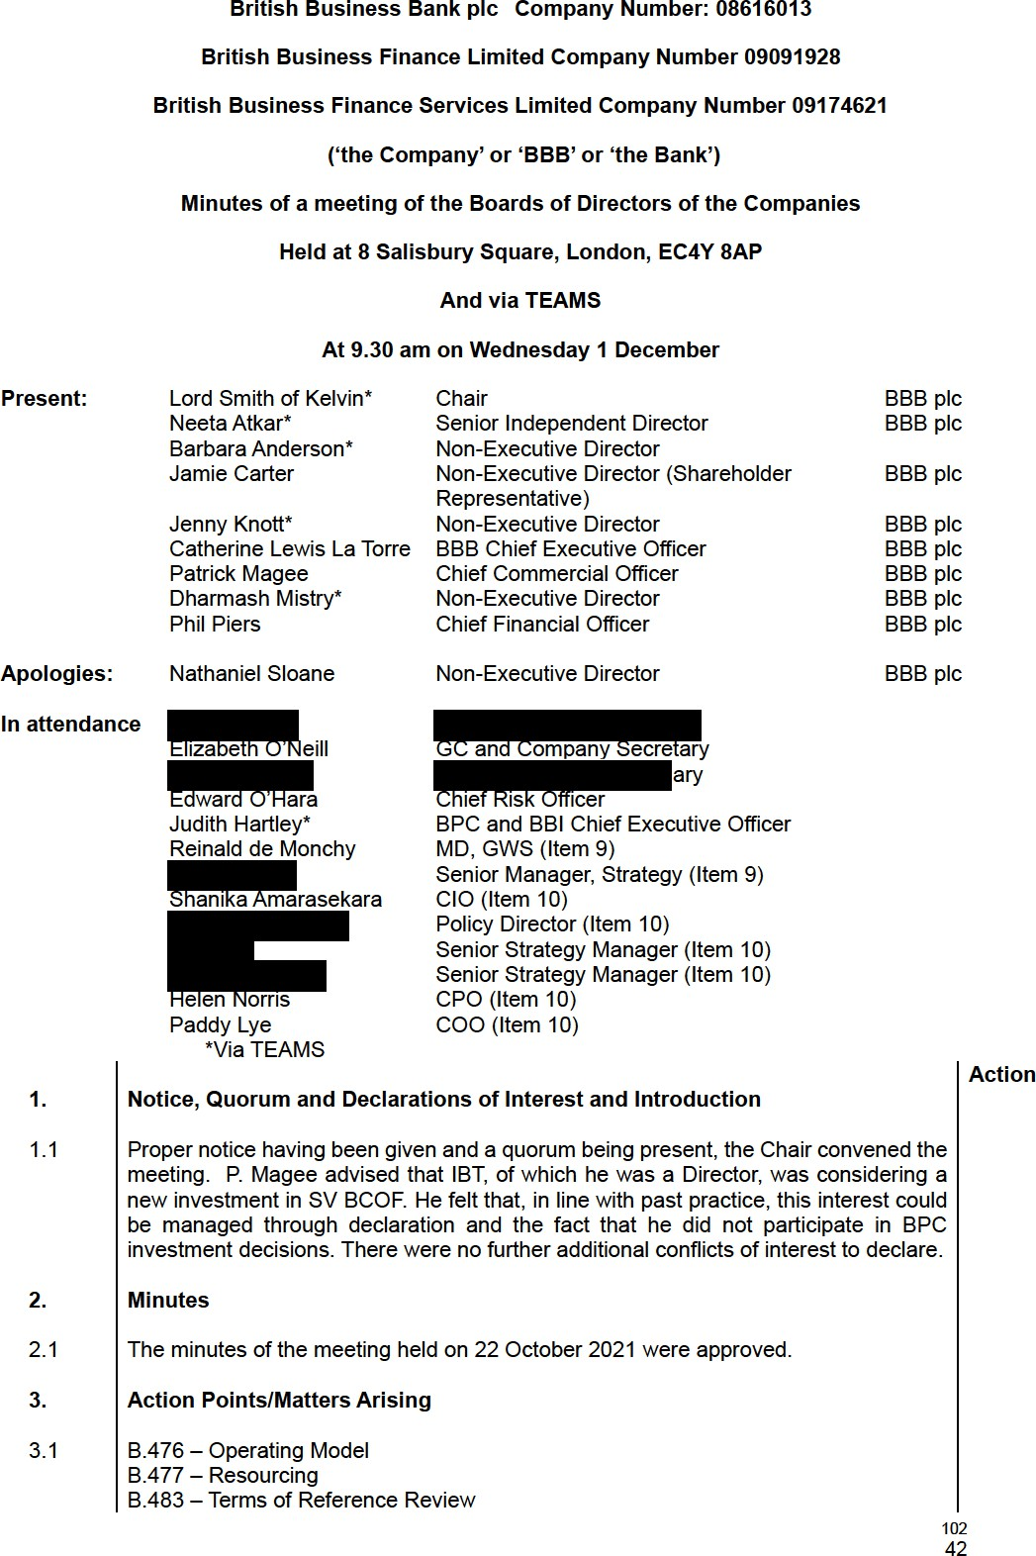
B.484 – Contract Day rates
B.485 – Encourage and Enable KPI Target
B.486 – Recovery Loan Scheme Extension
These matters were on the agenda to be discussed later in the meeting and the actions were closed.

  - B.481 Concentration risk – The matter had been discussed at the Board Risk Committee the previous day and an update would be provided later in the meeting. The action was closed.
  - B.487 BPC Strategy – Although the action was not yet due J. Hartley advised that discussions with C. Roxburgh of HMT had taken place and he had requested the process for developing the onward strategy for BPC be iterative, commencing in January. He had requested that an analysis of the VC market be commissioned, the scope of which was yet to be agreed. There was discussion regarding the establishment of a Board sub-committee to work with HMT. It was agreed this would be discussed with the Chair outside the meeting but that, in any event, the Board would be kept informed of developments.

  - B.488 Sustainability Charter – C. Lewis La Torre advised that the net zero six-point plan would be integrated into the overall business plan and the action was closed.

Chair’s Update

  - The Chair began by advising that he was scheduled to meet with the new Chair of UKGI later in the week.
  - He advised that the process of recruitment for a permanent CEO had commenced. A ‘beauty parade’ of potential recruitment consultants had taken place and a panel including BEIS and No.10 representatives had been established.

  - The appointment of James Connelly as a new Non-Executive Director had been approved. The date of appointment would be confirmed as soon as all checks had been completed.

  - An NSSIF lunch and learn had been arranged for after the Board meeting

Committee Update
Risk Committee
  - N. Atkar reported that the Risk Committee had met the previous day. The CRO report was included in the Board papers and would be discussed later in the meeting.
  - The Risk Appetite ‘path to green’ had been discussed at length with the focus being on operational and information risk. It was noted that it would take some time to return to green and agreed that the KPIs to measure progress should be reviewed.

  - There had been lengthy discussion regarding fraud and financial crime and the measures taken to strengthen the position. The ‘path to green’ would be discussed at the Risk Committee meeting in March. There had also been discussion regarding accountability in the portfolio operations team and it had been agreed that the framework would undergo further review and be considered further by the Committee.
  - The Committee had approved the revised Business Continuity Plan and Impact Analysis, and the regulatory requirements on operational resilience had been noted.
  - The Financial Risk policy had been approved.
  - There had been lengthy discussion regarding concentration risk and whilst it had been concluded that the introduction of hard limits was not appropriate, there was a need to ensure that a transparent framework was in place.
103

CEO Report

  - The report was taken as read and C. Lewis La Torre focussed on next steps following the Spending Review, the NAO investigation of BBLS, and HR changes.
Spending Review
  - C. Lewis La Torre explained the positive outcome from the recent Spending Review and highlighted the £1.6bn allocated to regional funding. She explained that the Bank was now exploring alternative solutions rather than merely building on what had done before with a view to maximising impact and outcomes. This would require strong stakeholder engagement to successfully achieve this.

NAO Investigation
  - Referring to the recent NAO investigation into BBLS which had focussed on fraud and the mitigating measures put in place, C. Lewis La Torre explained the specific criticisms and the areas where the comments from the Bank had been taken on board.

  - She reported that a press release was in the process of being prepared and this would be circulated to Board members later in the day.
HR Function
  - C. Lewis La Torre confirmed that the incumbent Chief People Officer would be leaving at the end of the year. She advised that the Bank had engaged a consultant, on an interim basis until a permanent Chief People Officer had been recruited, to review the structure and stabilise the department.

  - In addition, the Reward Director had announced his intention to retire later in the year. Steps to replace him were being taken to ensure there was an sufficient handover period.

  - There was a query regarding the output from COP 26. C. Lewis La Torre advised that the focus of the Bank would be on SME’s, and the ESG strategy would be integrated into the overall business and strategic plans. It was noted that there was a need to operationalise the statements made, and the amount of work to enable this was acknowledged. C. Lewis La Torre advised that a process was underway to recruit ESG specialists.

CFO Report

  - P. Piers reported that the Quarter 2 reforecast and Supplementary Estimates processes had been completed in November with the outcome being that there were no concerns with regard to year-end budget targets
  - P. Piers then moved on to discuss KPI 4 (Encourage and Enable). He explained that the Net Promotor Score is used to measure the outcome. The 21/22 target was initially determined by the results from the RepTrak surveys in FY 20/21. However, following a change in supplier to YouGov, methodological differences between RepTrak and YouGov in the calculation of the NPS had been identified which meant the original target was no longer appropriate. It was therefore proposed that the Bank should amend the measurement target and rebase the target for H2 21/22 against the results from H1 21/22.

  - He further advised that the intention was to look at the appropriateness of the measure going forward.
  - It was noted that any change would require ministerial approval. Given that it was eight months into the year and following due consideration, the Board rejected the proposal to re-baseline the NPS target using H1 results. The y/e 20/21 NPS score would remain as the baseline and the target. However, it was agreed that the Remuneration

104
Committee would take into account the methodological differences between the 2 NPS providers when considering the outcome of objective 4 at year end.

  - Moving onto the 2022/23 Business Plan, P. Piers reported that as part of the Spending Review settlement, HMT had agreed to remove the RLS operational expenditure ringfence and to allow the Bank to use potential underspends on core programmes to fund Covid activities, where necessary. This provided greater flexibility for the Bank to operate, and further discussions with HMT regarding the removal of all ringfences were underway.
  - It was reported that, given its growth, the Bank now fell under the requirement to publish payment metrics on its website. This was uploaded at the end of October and the data showed that BBB was in the top quartile of invoice payers in the last two years.

  - P. Piers then went on to report the financial performance of the business as detailed in the report, highlighting:
    - Performance against KPIs – mainly on or ahead of target;
    - Commitments – adverse to targets but strong pipeline maintains confidence in reaching full year targets; and
    - Costs – targets achieved.

CRO Report

  - Referring to the report E. O’Hara highlighted the three main messages that he wanted to bring to the attention of the Board relating to the path to green, the upward trending people risk and the volatile nature of reputational risk.
  - Referring to the path to green, E. O’Hara explained that there had been enhanced engagement with the teams across the Bank, initially focussing on areas where there was the biggest deviation and where it was felt biggest impact could be made. He reported that the Risk Committee, at its meeting the previous day, had discussed in detail both operational and information risk and would continue to keep progress against the path to green for all areas under close review.

  - E. O’Hara, referring to people risk reported increased attrition during the period at 10%, with some attrition being at more experienced hires and /high performers. This resulted in a widening of the gap between actual and budgeted headcount which gave rise for concern given the growth of the Bank and the resource intensive nature of some operations. It was noted that a paper on resourcing was due to be presented later in the meeting.

  - It was noted that reputational risk was being reflected as outside Risk Appetite following the publication of the PAC report on Greensill and the associated media coverage. The Board acknowledged that reputational risk would continue to be volatile depending on current events.
  - E. O’Hara reported the outcome of a recent meeting with Lord Agnew regarding the focus on fraud on the BBLS. He advised that the Bank had agreed to provide a lender fraud dashboard which would be subject to EARC approval and which BEIS and HMT had requested sight of prior to distribution. He highlighted that BEIS was accountable and responsible for BBLS fraud investigations.

  - Finally, E. O’Hara advised that he was seeking the approval of the Board for proposed changes to the Level 1 and Level 2 Risk Category definitions on Fraud and Financial Crime Risk, and an adjustment to the Risk Appetite levels on Fraud, to align to Financial Crime in relation to internal activities.

  - He explained that rationale for the changes, as detailed in the paper and following due consideration the Board RESOLVED to approve the changes as below.
105
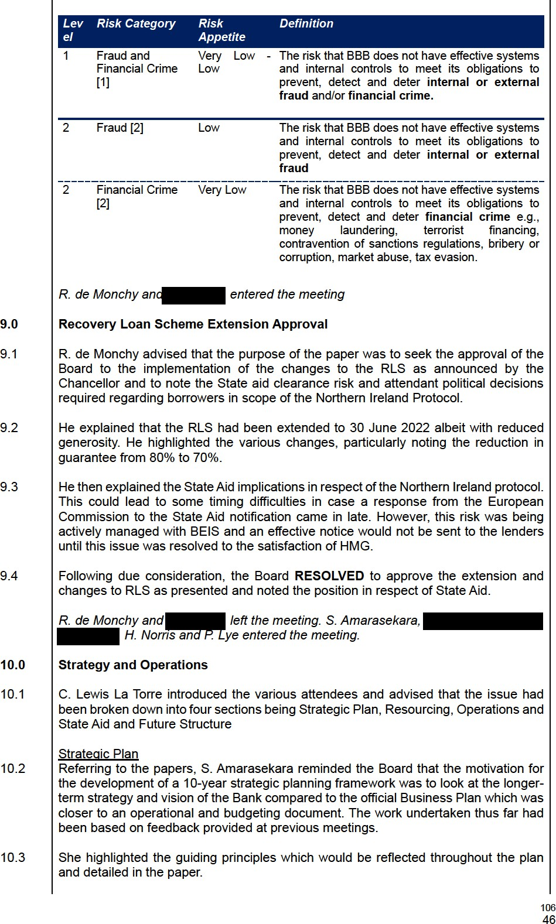
  - This led to discussion regarding the need for the plan to contain clearly articulated outcomes which would focus on ‘doing the right thing’ in respect of managing public money.

  - Several suggestions regarding some of the language used in the document were made and it was agreed that these would be taken on board and noted that the process of developing the plan would be iterative as trade-offs were continuously tested.

  - S. Amarasekara then highlighted the three pillars of the framework:
    - Championing sustainable growth;
    - Backing innovation; and
    - Breaking down barriers.
  - There followed lengthy discussion regarding the content of the pillars. There was a suggestion that ESG and diversity should be included as a guiding principle rather than a detail of the framework. C. Lewis La Torre explained that later on in the discussion she would be aligning products to the strategic pillars and this would explain why there should be a distinct pillar for breaking down barriers.

  - It was noted that the plan had been designed to align closely to the policies and ambitions of HMG.
  - The plan would be further developed for discussion at the Strategy Day scheduled to take place at the end January 2022.
Resourcing
  - P. Piers, referring to the paper, advised that its purpose was to provide an overview of total people resource utilised by the Bank focussing on the split between FTE, contingent labour and consultancy and professional services, growth in permanent FTE by function and brand and recent attrition.

  - He highlighted that there was no permanent FTE increase in the 2022/23 business plan and spend on consultancy and professional services was planned to reduce as the Covid-19 operational support began to unwind. In 2022/23 the aim was to further reduce spend on contingency labour, consultancy and professional services whilst increasing spend on permanent FTE which would beneficially impact cost, internal capability and colleague opportunities. It was agreed that there was a need to balance the FTE recruitment to end up in as optimal position as possible and reassurance was given that this would be closely monitored.
  - He went on to highlight the areas where additional staff were being recruited. This led to discussion regarding the relatively high spend on contingent labour and it was explained that this had been, to date, unavoidable but it was anticipated that the implementation of an improved operating model would have a positive impact.

  - The areas where reductions in professional services were highlighted.

  - The position regarding recruitment and attrition was noted and P. Piers explained the steps that were being taken to address the issues. It was also explained that there was a need to ensure the correct balance between front and back-office functions to ensure that the Bank’s operations were scalable.
Operations
  - P. Lye explained that the purpose was to explain and seek feedback from the Board that it was comfortable with the next transition state for the Bank’s Operating Model following implementation of the Covid response programmes.
  - P. Lye explained the reasons for changing the Operating Model which were 3 fold: 1) Transition Covid activities effectively to BAU, 2) Continue to enhance our control
environment and 3) increase efficiency and cost optimisation opportunities, enhance controls and improve efficiencies and cost control.
107

  - He explained the current state and the context to position the proposed changes were. He then explained the proposed changes, highlighting that four new functions were being proposed: middle office; bank-wide fraud and financial crime, data management office and operational control.
  - There was some discussion regarding the very wide remit of the Chief Marketing Officer (‘CMO’) and challenge as to whether there was sufficient capability and capacity. C. Lewis La Torre provided assurance that this had been considered and discussed with the CMO. It was felt that changes from project DIOR would alleviate the pressure and also the focus on demand and marketing may be less significant going forward, allowing capacity to focus on other areas within the remit.

  - NA and JK expressed reservations about proposal with regards to Fraud and Financial Crime position in the organisation. Following discussion PL agreed to come back to Board to discuss in more detail.
State Aid and Future Structure
  - C. Lewis La Torre explained that the purpose was to present a proposed future structure for the Bank to move it beyond the current State-Aid defined structure and to align operations to the new strategic framework underpinning the future Strategic Plan.
The content of the paper was noted and C. Lewis La Torre referred to a Powerpoint presentation made to the meeting.

C. Lewis La Torre explained that the simplification of our Corporate Structure could accomplish several goals including a closer alignment of the Bank’s activities with our Strategic priorities, the generation of synergies through the removal of historical state- aid silos and that cost savings could result from a more effective allocation of resources across the Bank.

11.0

11.1

Clarification of Group Governance

E. O’Neill introduced to the Board a number of governance matters that required clarification and approval, as detailed in the accompanying paper. E. O’Neill explained each of the matters which the Board considered in turn. Each of the BBFSL and BBB plc boards approved the matters as requested in the paper, including the delegations with respect to finalising and executing documentation (and including, in the case of BBB plc, for the Chief Commercial Officer or General Counsel, to execute the amendments to the Service Agreement on its behalf).

11.2
The following actions were taken to finalise the relevant governance documents: (1) In respect of the Shareholder Relationship Framework Document, for E. O’Neill to include an amendment acknowledging potential future changes to the Bank’s corporate structure and activities, in light of new subsidy control legislation, and potential future changes to the Bank’s spending threshold; (2) In respect of the NSSIF Service Agreement Addendum, for E. O’Neill and P. Magee to consider the appropriate amendments to the Addendum following the operational review of the BTIL/BBFSL mandate, which was expected to conclude in February 2022.
EON

EON

Delegated Financial Policy Approval

12.1
 presented the proposed updated Delegated Financial Authority Policy along with the cover paper which highlighted the key amendments to the Policy. The
Board discussed in detail the increase in limits to Annex 6 to allow for forecasted claims and BIPs payments in relation to the Covid Loan Guarantee Schemes to be made. N. Atkar asked the Executives if they were comfortable with the increased limits which C. Lewis La Torre confirmed they were.

108
12.2
An action was taken for E. O’Neill to consider whether individuals approving the anticipated large Covid Loan Guarantee Scheme claims have appropriate protection in place, if in the future anything was found to have been incorrectly paid. Following discussion, the Board APPROVED the updated Delegated Financial Authority Policy as recommended.
EON

Project Idaho
  - The meeting discussed the proposal for the private securitisations and concluded this was in line with the general strategy of the ENABLE Funding programme. There were some questions around market appetite, and the sequencing of doing some private securitisations first followed by a public securitisation. RdM noted that given the state of the economy it would make more sense to work with one or two sophisticated investors or banks first on a private transaction before going to the bond markets as these are less familiar with the asset class.

RLS Delivery Partner Allocation
  - The Board provided a series of questions and suggested to discuss answers to these during the next Board meeting given that there was not sufficient time left to discuss all the answers.

14.0 Any Other Business

4.1 There being no further business the meeting ended.

109
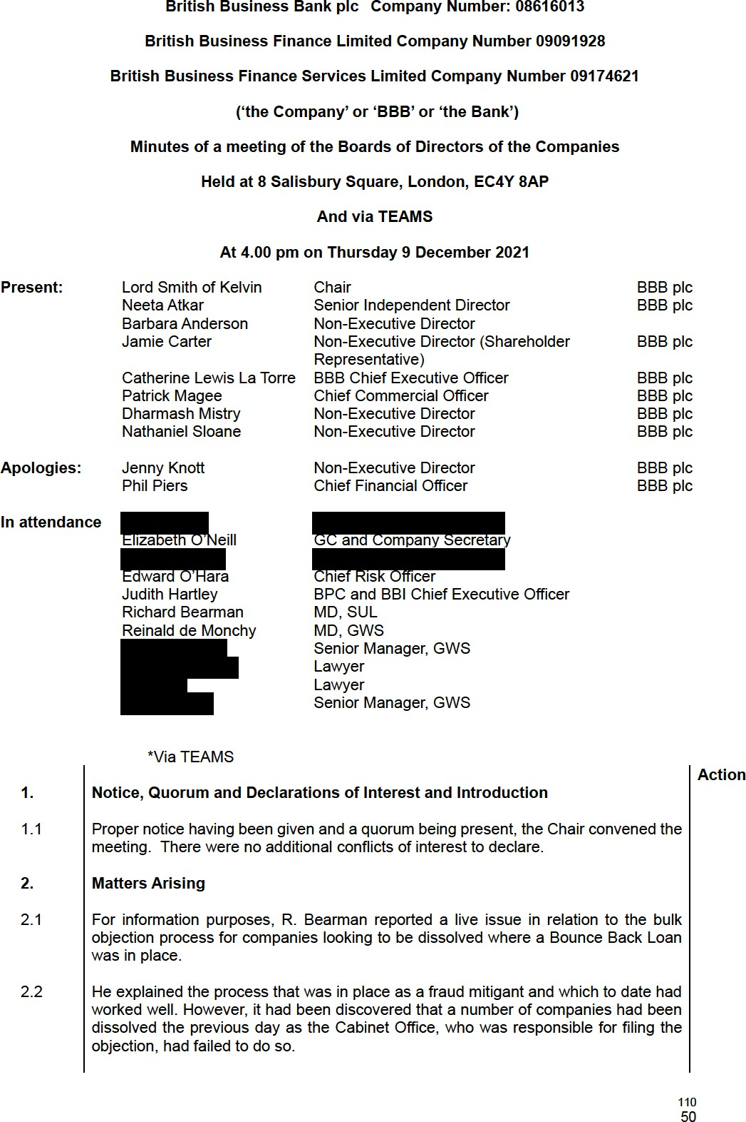
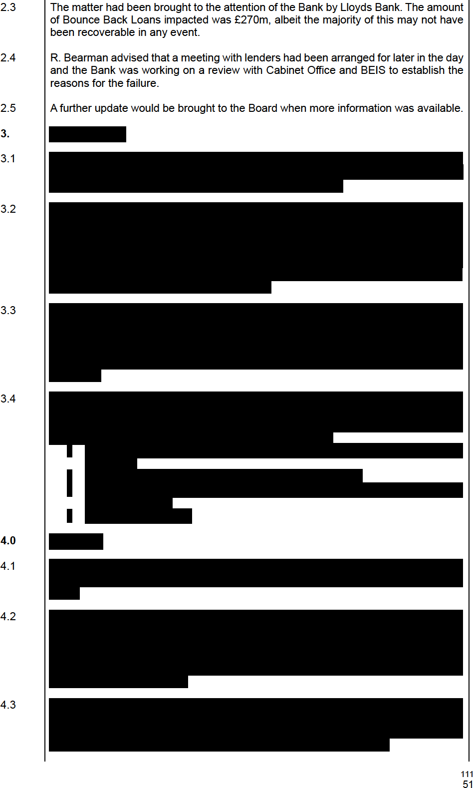

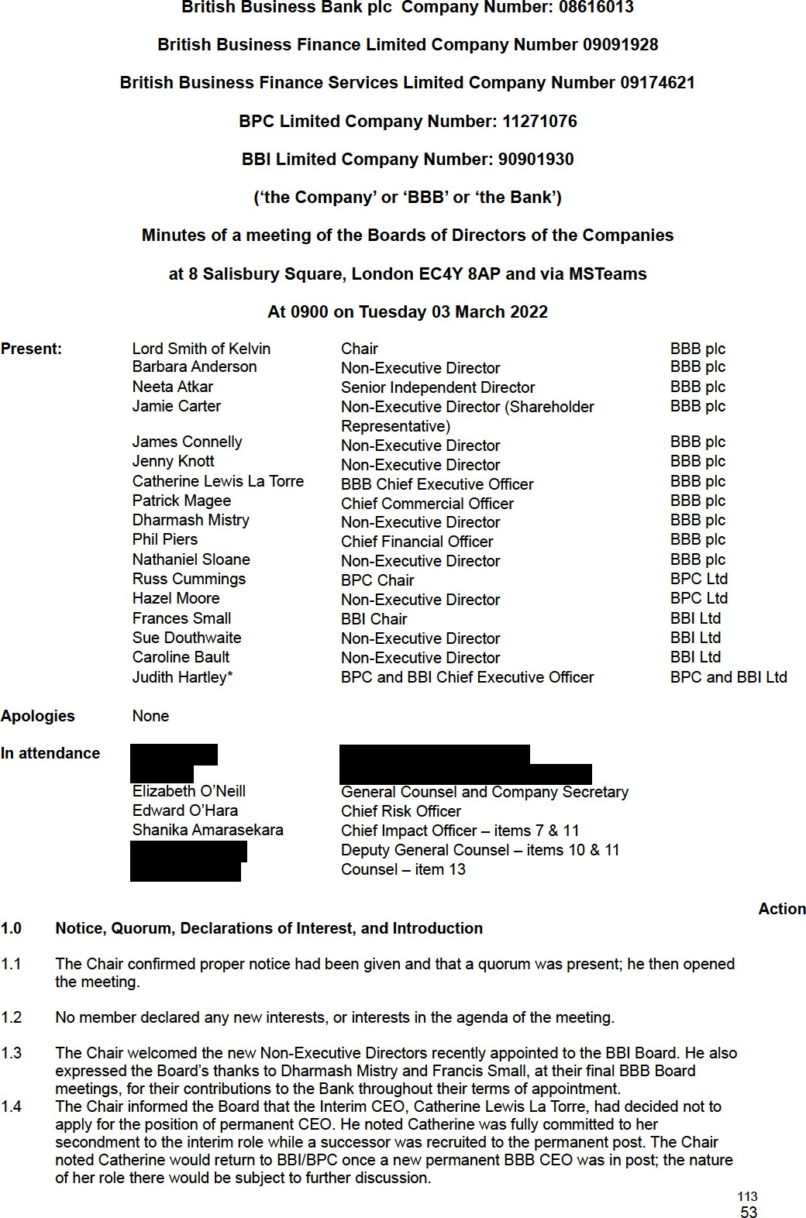
  - Approval of Minutes

  - The Minutes of the meeting held on 08 February 2022 were approved.

  - Matters arising

  - Action B.492: CLLT noted a meeting would be held with the Secretary of State, BEIS, on 14 March 2022 to discuss the Bank’s role in supporting the UK economy achieving its targets on net zero. It was agreed to close the action.
  - Action B.493: the Chair of the Board had met with the Interim Head of HR. It was agreed to close the action.
  - Action B.494: the relevant letters had been uploaded to Diligent for the Board’s information. It was agreed to close the action.

  - Action B.495: the Chair and CLLT would discuss Covid debt programmes governance at their meeting on 14 March 2022 with the Secretary of State, BEIS. It was agreed to close the action.

  - BBB plc Chair’s update

  - The Chair referenced his remarks at 1.3 and 1.4 above. He noted a letter had been sent to the Secretary of State, BEIS on the matters the Bank wished to discuss at their meeting on 14 March 2022.

  - Board Committees – verbal updates

  - Remuneration Committee, 01 March 2022
BA noted this had been the first Committee meeting with the new Interim Head of HR in post. Useful diagnostics were now being received and an action plan developed to address the key issues.
The Committee had:
    - recommended changes to the Remuneration Policy subject to clarifications on the long-term incentive plan.
    - discussed, and was supportive of, the recruitment to eight posts at managing director level.
    - approved the remuneration for the MD, Middle Office, and also the MD, Sustainability as a one- year fixed-term contract focusing on embedding sustainability practice across the business.
    - noted the Gender Pay Gap report and that good progress had been made.

  - Risk Committee, 02 March 2022 The Committee had:
    - discussed the CRO’s report and noted the emphasis on organisational stretch. An update on the impact of the situation in Ukraine was also received.
    - noted progress on the Covid loans performance, and that data and analyses were now enabling deeper insight.
    - agreed changes to the risk taxonomy. The Committee had asked that the taxonomy be reviewed to ensure it was fit for purpose.
    - reviewed all PTG apart from people risk which the Committee would consider at its next meeting. In relation to the PTG for Fraud and Financial Crime (F&FC), the Committee had noted the need for agreement and clarity with the Shareholder on the level at which the Bank should be managing and administering the risk.
    - reviewed strategic & business, and legal & compliance risks. The Committee had asked management to review the underlying taxonomy on strategic & business risk.
    - endorsed the risk activities plan for the first and second lines of defence, 2022-23.
    - received an update on the Delivery Partner monitoring programme.
    - approved (i) revised Information Risk Framework, (ii) revised Reputational Risk Policy (iii) new Risk Management Framework, and (iv) the Risks Appetite Policy which moved reputational risk from low/medium to medium.

  - The Board approved the revised Risk Committee Terms of Reference.
  - The Board discussed the change in risk appetite in relation to the Covid schemes. NA noted that early data showed the relative losses of the big banks reflected their own risk appetites, while losses were higher at the challenger banks. EOH noted the expected rate of credit losses had reduced, and economic conditions had improved, notwithstanding the developing situation in Ukraine.
114
  - JCa asked if we had insight into whether banks might be protecting their own loan books at the expense of the government guarantee. EOH noted we did not have access to this level of information.

- CEO report
  - CLLT highlighted key elements of her report: (i) success in reducing the gender pay gap, though further progress was needed, (ii) a successful launch of the annual Small Business Finance Markets reports which received strong support from Paul Scully MP (Minister at BEIS), and (iii) progress in finalising the Business Plan for Board approval.
  - CLLT noted the F&FC team was being strengthened and the Remuneration Committee had agreed a new role - MD, F&FC. She noted HMT had encouraged the Bank to bid for funds to further develop the F&FC team and capabilities, and a bid would be submitted shortly. JCa noted the opportunity to clarify the Bank’s F&FC objectives. The Board noted the bid would seek to deepen the areas for which it was already responsible, and noted lender performance was a priority area. The Chair noted the Bank would respond proactively to HMT’s request while noting the need to clarify the Bank’s role and operational independence.

  - EON noted that internal and external governance would be structured appropriately as the F&FC remit was developed; she noted cross-government interest in oversight of the approach and implementation of the Bank’s F&FC remit going forward. She noted that internal governance of same also required further development to reflect changes and provide consistent strategic decision making. NA noted it was important that stakeholders saw the Bank being rigorous in self-analysis and evaluation of the work done internally .

  - JKn asked if there were roles for the FCA and PRA in addressing those F&FC issues of government concern. CLLT noted she had met with the FCA and that BEIS were considering how such institutions could be involved.
  - CLLT noted the Remuneration Committee had approved the recruitment of nine roles at managing director level. The Committee had also agreed that salary levels of key and critical roles should be addressed within a segmented approach to salaries across the business.

  - JKn commended the strategic plan and framework and asked if further clarification on the nature of the Bank could be included, e.g. whether a development bank, or sovereign wealth fund. CLLT noted the strategic plan and objectives provided the definition of the Bank’s role but that further descriptors could be helpful in communicating to entrepreneurs, SMEs, as well as government stakeholders. The CMO would be invited to attend a future meeting to update the Board. JCo noted the Covid loan schemes, SUL and other programmes had saved and made a significant difference to many thousands of businesses across the country and there would be many positive stories to tell.
- CFO update – PP’s comments incorporated

  - The Board approved the BBB Tax Strategy for the financial year ending 31 March 2022.

  - On financial performance PP noted a £7mn underspend in BAU costs for 2021-22 due to fewer people being recruited and lower legal fees. He highlighted a slight negative movement on KPI 3 – Regionality. HM suggested there was an implication that BPC had not reached target, while not actually having a regional target. CLLT noted the target was for the Group and that the regional impact through the commercial arm was largely driven by BBI initiatives; BPC’s focus was on investing alongside the private sector, and venture capital investments tended to be more geographically concentrated in London and the South East. PP agreed to reflect accordingly in future commentaries.

CLLT

PP
  - DM referred to KPI 6 – Adjusted Rate of Return. He noted the anomaly of the very high returns for the current 12-month period and that the context must be clearly understood by government. PP explained this was the reason for seeking a cumulative returns target over DMO benchmark.
  - PP noted the cost underspend on the Covid schemes has been driven by three factors: (i) the lender assurance programme costs had been lower than planned due to delays in audit completion;
(ii) cost efficiencies had been identified in the PwC operation centres; and (iii) the fraud sampling for CBILS and CLBILS had been moved to 2022-23. PP noted these issues would not cause pressure in the next financial year.
  - On the Business Plan, PP noted Board approval was sought for the proposed solution to the £12mn RDEL funding gap in 2022-23, and for proposed changes to KPIs. He noted the plan was still in 115
55
draft as: strategic input and narrative was being provided by HMG, the new FTE cap number was still being finalised, and there were some proposed shifts in strategy that would require Board approval. He noted that while the Bank was required to produce a five-year Business Plan, it was aligned to the three-year CSR settlement 2022-25.
  - PP drew attention to four key topics which were then discussed by the Board: priorities, which included Path to Green, F&FC, and Change initiatives including efficiency drivers; proposed areas to deprioritise, which included the marketing budget, Centre of Expertise, and ESG; a people strategy to ensure capacity to deliver the plan, including how to address associated risks; and the proposed associated changes to KPIs.
  - The Board agreed that the current Business Plan be further developed as proposed. PP noted it would be updated and presented to the Board for approval at its meeting on 14 April 2022, and then go to BEIS for approval. The Board commended the management teams for their work on the Business Plan.
- CRO update – EOH edits incorporated

  - EOH highlighted two areas for the Board’s attention; the Path to Green (PTG), and risks associated with the conflict in Ukraine. The PTG, based on the Business Plan, detailed the plan and key dependencies and constraints in returning to risk appetite within the financial year. He noted the RDEL funding shortfall, and the FTE cap were key uncertainties. EOH noted that operational and information risks were on target, and good progress was being made on F&FC; people risk had not been updated in order to give the new Interim Head of HR time to assess the situation and develop plans.

  - In relation to the conflict in Ukraine, EOH highlighted that the key risk was reputational risk with financial risks currently estimated to be circa £1m to Russian domiciled counterparties. There was currently no direct exposure to sanctioned individuals, and he also noted there was no direct exposure to Ukrainian or Belorussian counterparties. EOH noted the information risks related mostly to cyber threats. The Bank had had discussions with BEIS and the National Centre for Cyber Security, and 24-7 monitoring of our IT estate was in place. While risks had increased, EOH noted that appropriate actions had been taken to address them.
  - JKn asked what our impact tolerance was in relation to cyber security and in the event of any such cyber-attack would it cause an “intolerable level of harm” as defined by the FCA. EOH confirmed the Bank had multi-factor identification, and the level of harm would depend on the nature of any attack however we did not deem any of the Bank’s critical activities as “important business services”
as defined by the FCA. The Board asked EOH to assess the intolerable harm threshold. EOH
  - On legal and compliance risks, EOH confirmed that checks of Russian, Ukrainian, and Belorussian shareowners had identified 72 individuals, none of whom were currently sanctioned. He noted the Bank would automatically receive an alert from Bureau Van Dyke if any became sanctioned. EOH highlighted the potential reputational damage associated with the Bank’s DPs; he confirmed the Board Risk Committee had requested confirmation from all DPs that there were no sanctioned individuals on their books. BA suggested professional services companies be asked to confirm the
same; EOH noted this would be reviewed. EOH

- Commercial Arm update – JH edits incorporated

  - JH drew out key points in relation to BBI. She noted the intention to continue to grow the business even though the business plan appeared to show reducing commitments over future years. This was due to uncertainty regarding future availability of capital, with only agreed capital included in the plan. She highlighted that, given the high volume of capital distributions from BBI investments over the next five years and also BBI’s capacity to generate profit for the group, there was a strong case to recycle these capital distributions back to BBI for further investment. She noted that BBI was well- placed to address the regionality and levelling-up agendas and that its mission statement, systems and processes were being updated to more explicitly recognise this policy driver.
  - JCa asked if these changes would affect investment decisions noting the importance of BBI in generating RDEL for BBB. JH noted the BBI Board had agreed to give preference to bidders demonstrating regionality and/or diversity and inclusion and/or net zero but that further work was needed to embed these into BBI’s assessment and due diligence processes and procedures.

  - JH confirmed the BPC Working Group had been established to provide input to the BPC strategic review. She noted HMG had indicated there was no plan to sell BPC in the short or medium term.
116
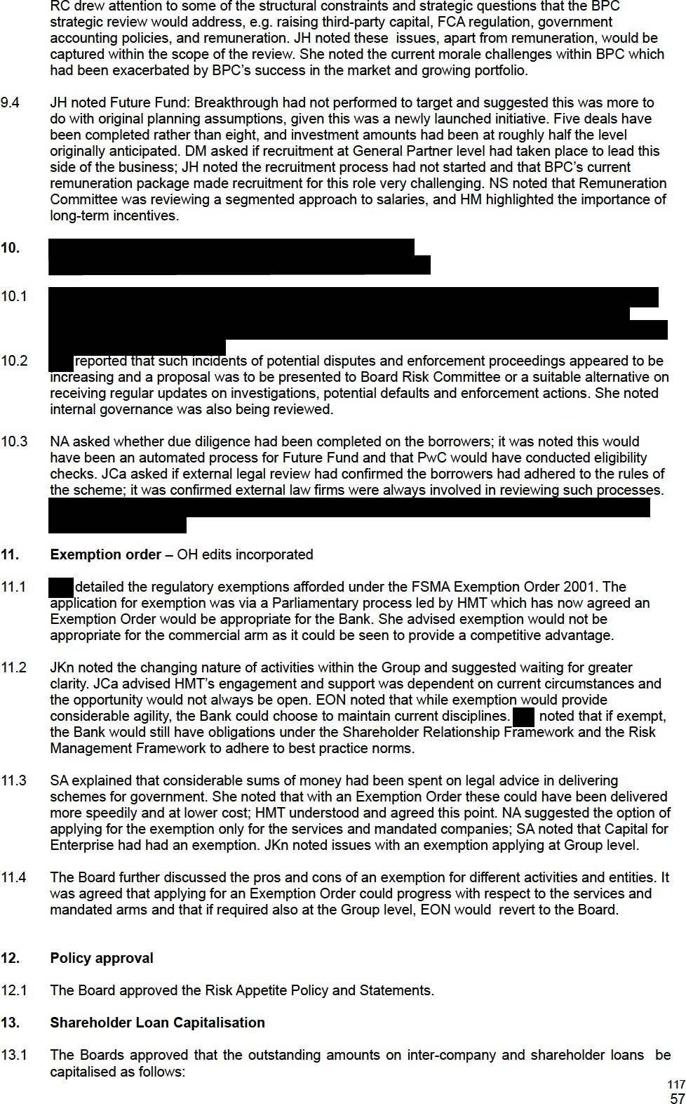
    - £295,600,000 due to the Secretary of State for Business Energy and Industrial Strategy (‘BEIS’) from BBB;
    - £21,100,000 due to BBB from BBFL;
    - £213,800,000 due to BBB from Holdings; and
    - £204,800,000 due to Holdings from BPC.

  - Any other business

  - There was no further business and the meeting closed.

118

