Reference FOI 23-031

16 August 2023

RE: Freedom of Information Request
Thank you for the freedom of information request received by the British Business Bank (BBB) on 01 August 2023, where you requested:
“I'm looking to understand what your organisation is spending on Salesforce products between the dates 1st August 2019 to 1st August 2023. This includes all quotes (preferably in PDF format) with associated costs, units and discounts relating to Salesforce products (which could include) -

1. Salesforce Sales Cloud
2. Salesforce Service Cloud
3. Salesforce Revenue Cloud
4. Salesforce Marketing Cloud
5. Pardot
6. Salesforce Experience Cloud
7. Commerce Cloud
8. Salesforce Analytics Cloud
9. Salesforce Apps Cloud
10. Salesforce IoT Cloud
11. Tableau
12. MuleSoft

(these will likely be billed together)

I am investigating your organisation's Salesforce costs against other organisations in assessing if you are getting value for money from Salesforce.”

Response:
Under the Freedom of Information Act 2000 (‘FOIA’), you have the right to:
- know whether we hold the information you require, and
- be provided with that information (subject to any FOIA exemption).

In response to your question, we have checked our records and collated the relevant information.

The table below shows the actual spend and we have provided screenshots from the invoices of the lines of spend for the different products for each financial year.

Actual Spend

Period | Spend
19/20 | 315,203
20/21 | 458,425
21/22 | 549,210
22/23 | 659,314

Quotes

2019-2021 SULCo Salesforce quote (2 year quote)
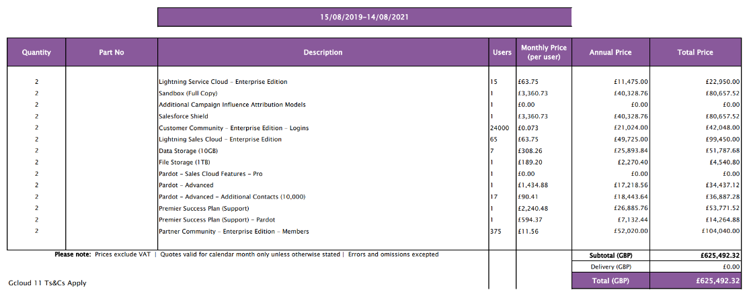

2021-2022 SULCo Salesforce quote
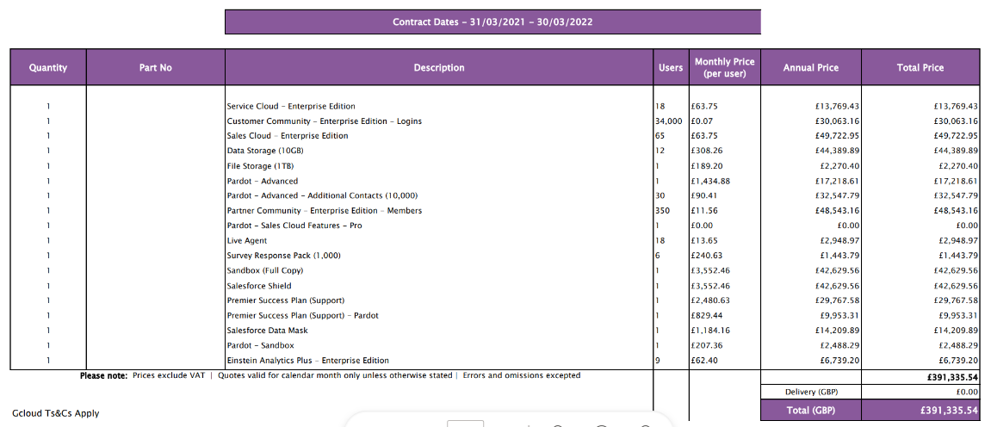

2022-2023 SULCo Salesforce quote
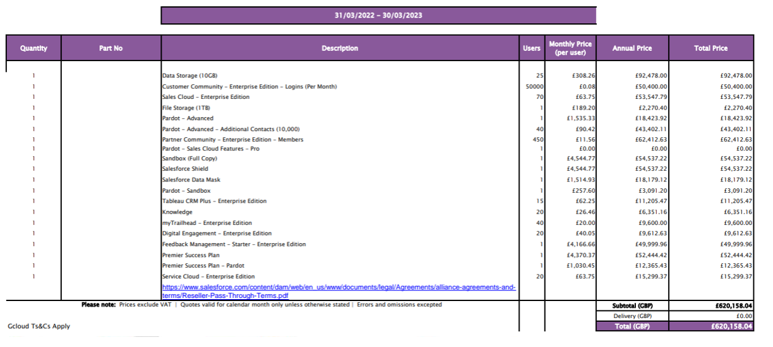

2023-2024 SULCo Salesforce quote
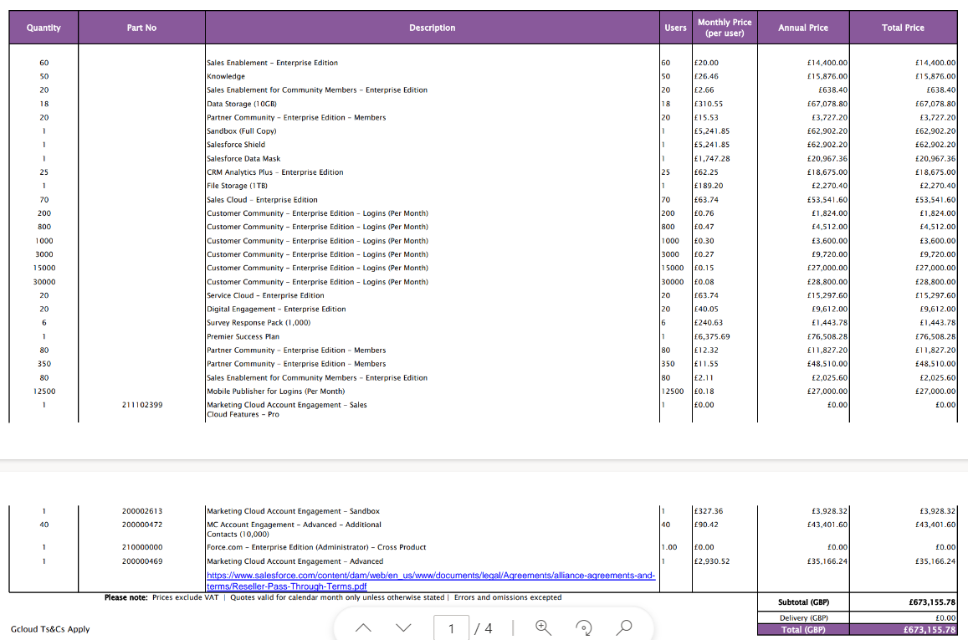

2020 – 2021 BBB Future Fund platform
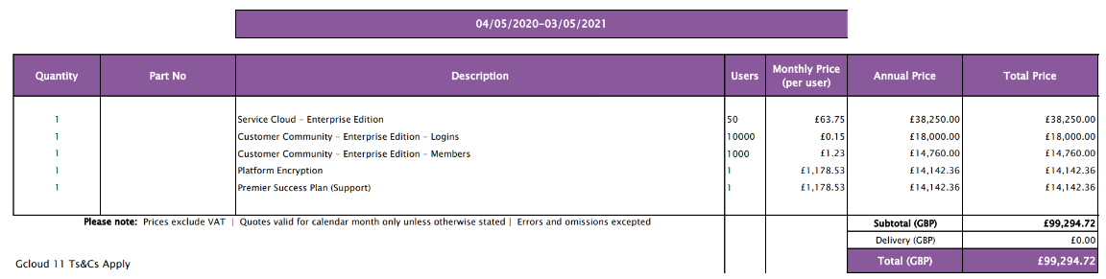

2021 – 2022 BBB Future Fund platform
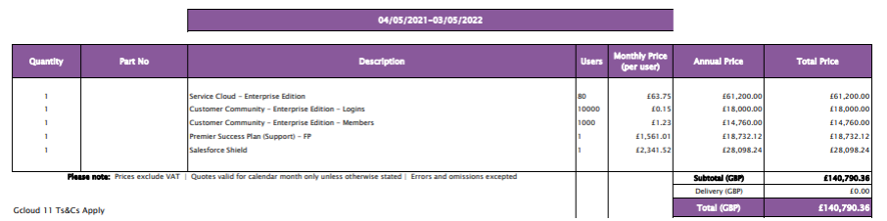

2022 – 2023 BBB Future Fund platform
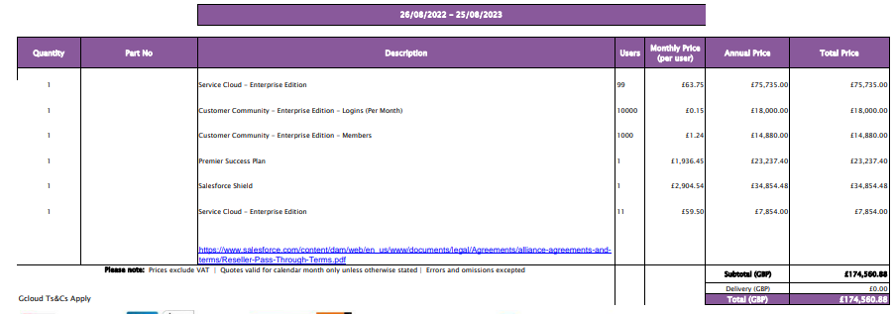

2023 – 2024 BBB Future Fund platform
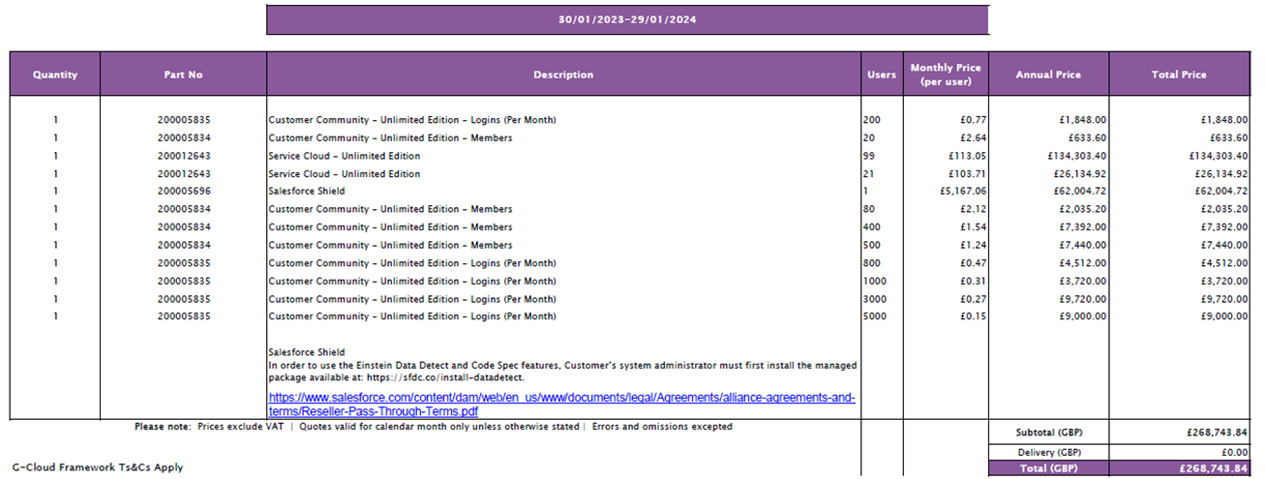

If you have any queries about the handling of your request, please let us know.

Your right to an Internal Review under the Freedom of Information Act
If you are dissatisfied with the handling of your request, you have the right to ask for an internal review. Internal review requests should be submitted within two months of the date of receipt of the response to your original letter and should be addressed to:
FOI Officer,
British Business Bank,
Steel City House,
West Street,
Sheffield,
S1 2GQ or
foirequests@british-business-bank.co.uk.
Please remember to quote the reference number above in any future communications.
If you are not content with the outcome of the internal review, you may apply directly to the Information Commissioner’s Office (ICO) for a decision. The ICO cannot help you until you have completed our internal review procedure. The ICO can be contacted at:
The Information Commissioner’s Office,
Wycliffe House,
Water Lane,
Wilmslow,
Cheshire
SK9 5AF or
see their website for alternative contact details: www.ico.org.uk.
Yours sincerely,
FoI Officer
British Business Bank

