Reference FOI 22-081

16 December 2022

RE: Freedom of Information Request
Thank you for the freedom of information request received by the British Business Bank (BBB) on 30 November 2022 and further clarified on 1 December 2022 where you requested:
“The information I require was publicly available in 2009-10 and in 2014 when BBB first launched, it’s just it’s impossible to locate it on the internet now.

I am looking to receive all details about the Enterprise Finance Guarantee Scheme (EFGS) from the early days of the scheme ie from when it was launched in 2009 until the end of 2010 (when it was overseen by the Department of Business, Innovation & Skills) and also from when British Business Bank took over running of EFGS in 2014.

I am particularly interested in eligibility criteria about EFGS - ie what companies were eligible for it and what factors made companies ineligible for it.

It is possible to find information about EFGS on the internet but this is later information, and I am looking for information from the early days of the scheme (2009-10) and from when BBB first took it over in 2014.”

After clarification:

“I think if you provided all publicly available information on EFGS (during the requested time periods) then eligibility criteria would be covered.
For example, EFGS was initially overseen by the Department of Business, Innovation & Skills (“BIS) from when EFGS was introduced in early 2009 until 2014.
The only details I can find online were the guidance notes issued by BIS:
https://www.gov.uk/guidance/understanding-the-enterprise-finance-guarantee
This guidance was published in 2014 but older versions are not available online and I am interested in the guidance document’s equivalents from the beginning of EFGS in early 2009 until the end of Q1 in 2010.
Secondly, I am interested in the equivalent guidance documentation from when BBB took over the oversight of EFGS in 2014.
This BBB document is available online:
https://www.british-business-bank.co.uk/ourpartners/supporting-business-loans-enterprise-finance-guarantee/about-efg/
Within this document there is a link to further eligibility requirements of EFGS:
https://www.british-business-bank.co.uk/wp-content/uploads/2019/04/190401-EFG-Request-for-Proposal-Final.pdf
The first link is to a page that was last updated in 2017 and the second link is to a document that was dated in 2019. I am seeking the equivalent document(s) from when BBB took over EFGS in November 2014.”

Response:
Under the Freedom of Information Act 2000 (‘FOIA’), you have the right to:
- know whether we hold the information you require, and
- be provided with that information (subject to any FOIA exemptions)
I can confirm that BBB holds information within the scope of your request.
The guidance notes you referred to in your clarification on 01 December 2022, hosted on gov.uk, were withdrawn on 8 September 2014. As you identified, scheme information remains available on the BBB website and in the “Request for Proposal” document, which lending institutions used to apply to partner with BBB and deliver the Enterprise Finance Guarantee (“EFG”):
- Enterprise Finance Guarantee - About EFG
- EFG Request for Proposal Final.
As the BBB took over administration of a scheme that was already in place in 2014, no new guidance was issued at that time.
A range of further documentation on EFG is also available:
- Economic evaluation of the enterprise finance guarantee scheme
- Enterprise Finance Guarantee Brochure March 2019
- Enterprise Finance Guarantee quarterly statistics
To be eligible for support via EFG, the requirements were that the small business must:
- be UK based, with turnover of no more than £41 million per annum
- operate within an eligible industrial sector (a small number of industrial sectors are not eligible for support)
- have a sound borrowing proposal but have inadequate security to meet a lender’s normal requirements
- be able to confirm that they have not received other public support of de minimis state aid beyond €200,000 equivalent over the previous three years
BBB does not hold guidance documentation from 2009 to 2010. As you have identified, the guidance issued in 2014 sets out that a number of sectoral restrictions had been lifted:

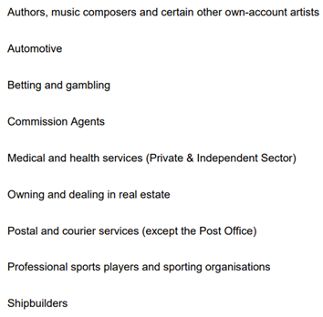

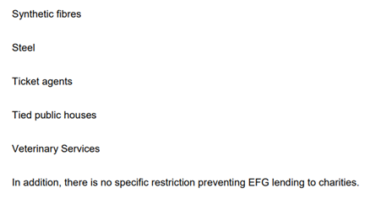

If you have any queries about the handling of your request, please let us know.

Your right to an Internal Review under the Freedom of Information Act
If you are dissatisfied with the handling of your request, you have the right to ask for an internal review. Internal review requests should be submitted within two months of the date of receipt of the response to your original letter and should be addressed to: FOI Officer, British Business Bank, Steel City House, West Street, Sheffield, S1 2GQ or foirequests@british-business-bank.co.uk.
Please remember to quote the reference number above in any future communications.
If you are not content with the outcome of the internal review you may apply directly to the Information Commissioner’s Office (ICO) for a decision. The ICO cannot help you until you have completed our internal review procedure. The ICO can be contacted at: The Information Commissioner’s Office, Wycliffe House, Water Lane, Wilmslow, Cheshire SK9 5AF or see their website for alternative contact details: www.ico.org.uk.
Yours sincerely,

FoI Officer
British Business Bank

