Reference FOI 22-099

03 March 2023

RE: Freedom of Information Request
Thank you for the freedom of information request received by the British Business Bank (BBB) on 07 February 2023, for:
“Please can I have details of the covid loans issued to Lincolnshire businesses:

1. The number of loans issued in total (CBILS/BBL) and the total value
2. The number of these that have been paid back in full and the value repaid

And nationally:

3. The number of loans issued in total (CBILS/BBL) and the total value
4. The number of these that have been paid back in full and the value repaid

Please provide the most up-to-date figures available, and indicate what date the figures are based on.”

Response:
Under the Freedom of Information Act 2000 (‘FOIA’), you have the right to:
- know whether we hold the information you require, and
- be provided with that information (subject to any FOIA exemptions).

We can confirm information is held and is as follows:
Please can I have details of the covid loans issued to Lincolnshire businesses:

1. The number of loans issued in total (CBILS/BBL) and the total value

Type | Location | Scheme | Number of Facilities | Loan Amount
Drawn | Lincolnshire | BBLS | 14721 | £416,796,692
Drawn | Lincolnshire | CBILS | 962 | £235,664,946
 |  |  | 15683 | £652,461,638

2. The number of these that have been paid back in full and the value repaid

Type | Location | Scheme | Number of Facilities | Loan Amount
Fully Repaid | Lincolnshire | BBLS | 1670 | £51,205,376
Fully Repaid | Lincolnshire | CBILS | 291 | £80,767,915
 |  |  | 1961 | £131,973,291

The information for Questions 1 and 2 for Lincolnshire is as of 06 February 2023. “Drawn” means all facilities that have seen funds drawn down by borrowers, including those that have also fully repaid.

And nationally:

3. The number of loans issued in total (CBILS/BBL) and the total value

The number of facilities and their values awarded in total for the CBILS/ BBLS facilities are in the tables below. The data is taken from the Government’s website that publishes performance data on the Covid-19 loan schemes (see hyperlink in the answer to your question 4 below).

The first table shows the total number of facilities across all three loan schemes including BBLS, CBILS and CLBILS, and the data in tables 6 and 8 (CBILS and CLBILS respectively) will allow you to calculate the total number and value of the BBLS facilities.

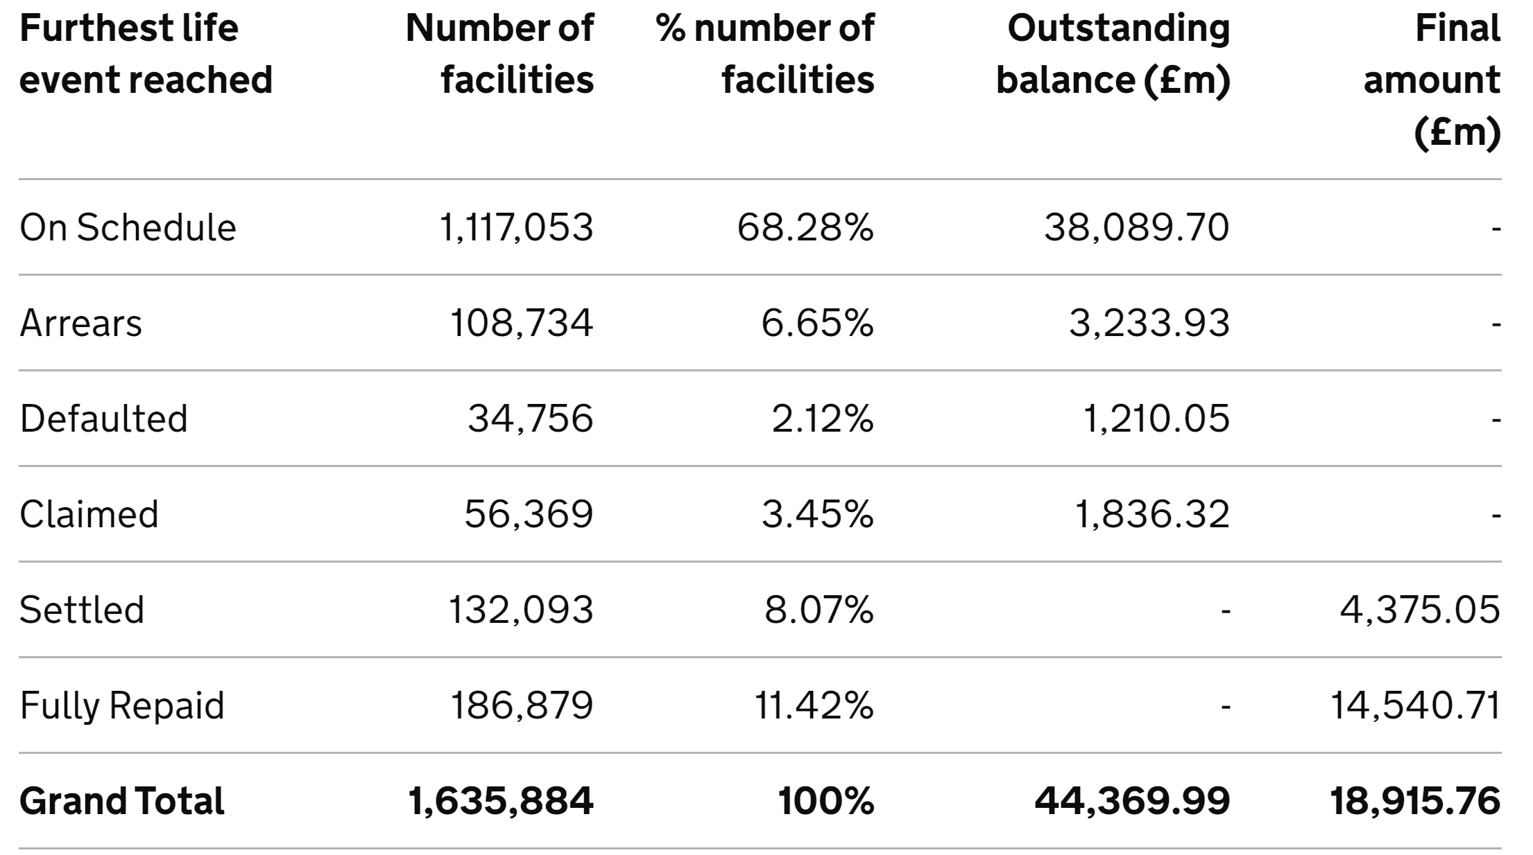 | 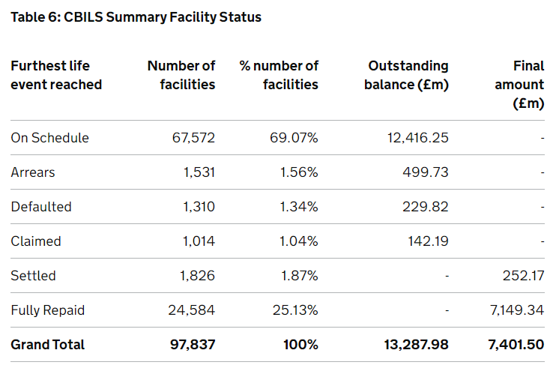 | 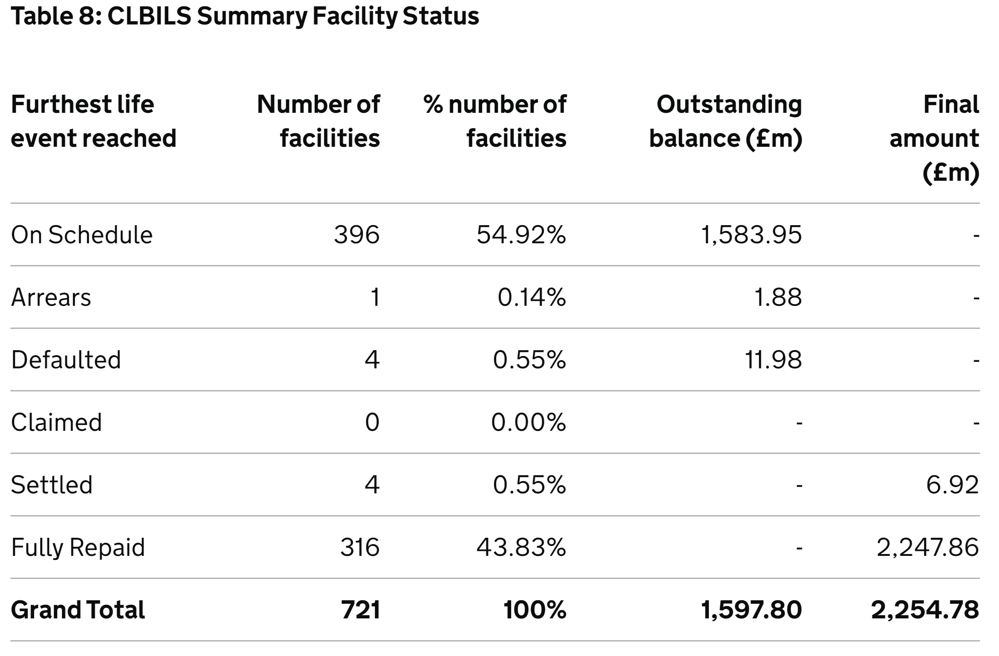

4. The number of these that have been paid back in full and the value repaid

Please see Question 3 above.

The information in response to Questions 3 and 4 is updated every quarter and the current information was published on 06 February 2023 for the period to 31 December 2022: COVID-19 loan guarantee schemes performance data as at 31 December 2022 - GOV.UK (www.gov.uk).

Please note the information provided for Questions 3 and 4 is as of 31 December 2022 and the information for Questions 1 and 2 is as at February 2023. We have decided that it would not be appropriate to provide the most up to date figures for Questions 3 and 4 because the information is published on a three-month schedule along with lender performance data and to publish data outside of the reporting cycle distorts the accompanying information about lender performance.

When we refuse to disclose information in scope of the request, we are required to provide a refusal notice to explain what exemption applies and why. Please see the refusal notice below.

If you have any queries about the handling of your request, please let us know.

Your right to an Internal Review under the Freedom of Information Act
If you are dissatisfied with the handling of your request, you have the right to ask for an internal review. Internal review requests should be submitted within two months of the date of receipt of the response to your original letter and should be addressed to: FOI Officer, British Business Bank, Steel City House, West Street, Sheffield, S1 2GQ or foirequests@british-business-bank.co.uk.
Please remember to quote the reference number above in any future communications.
If you are not content with the outcome of the internal review, you may apply directly to the Information Commissioner’s Office (ICO) for a decision. The ICO cannot help you until you have completed our internal review procedure. The ICO can be contacted at: The Information Commissioner’s Office, Wycliffe House, Water Lane, Wilmslow, Cheshire SK9 5AF or see their website for alternative contact details: www.ico.org.uk.
Yours sincerely,
FoI Officer
British Business Bank

Refusal Notice - FOIA section 22 (Information Intended For Future Publication)
Why does it apply
We are applying Section 22 exemption for the information requested under Questions 3 and 4 for the most up to date figures for the number and value of the CBILS and BBLS issued and repaid because the information is intended for future publication.
Section 22(1) of the FOIA states that information is exempt from disclosure if;
- the information is held by the public authority with a view to its publication, by the authority or any other person, at some future date (whether determined or not)
- the information was already held with a view to such publication at the time when the request for information was made, and
- it is reasonable in all the circumstances that the information should be withheld from disclosure until the date referred to in paragraph (a)
Reasons for applying the exemption
We routinely publish information about the Covid-19 loan schemes including the number and value of the facilities awarded, repayments, arrears, and suspected fraud. The information you requested forms part of the dataset and to release an update to a proportion of the data potentially undermines the information already published and disrupts the scheduled reporting cycle. The criteria of Section 22(1) are met, and we are therefore applying the exemption.
Public Interest Test
Section 22 is a qualified exemption, and we are required to carry out a public interest test to consider whether it is in the public interest to disclose the information as per your request or to maintain the exemption. The public interest test considers the circumstances of the request and weighs the public interest in maintaining the exemption against the public interest in disclosure. The public interest means the public good, not what is of interest to the public nor the private interests of the Requestor.
The public interest test in favour of disclosure
There is an inherent public interest in
- the way public bodies operate, make decisions, and spend public money
- enabling members of the public to ask questions of public bodies and engage in democracy
- understanding the effectiveness and impact of multi-million pound government schemes
The public interest test in favour of maintaining the exemption
- our existing commitment to publish Covid scheme performance information every three months
- the Covid-19 loan schemes have been subject to scrutiny by National Audit Office, Public Accounts Committee, and Select Committees
- the release of information outside of the scheduled disclosure creates work and potentially undermines the reporting cycle
On balance
Given the routine publication of covid-19 loan information and the nature of the information published, for example the details provided per lender, there is a risk that premature or partial disclosures of data intended to be published creates additional work for the public body and potentially undermines the scheduled disclosures. Also, given the information available is relatively recent (as of 31 December 2022), the public interest weights in favour of maintaining the exemption and not to release the most up to date figures for Questions 3 and 4.
Right to Review
As confirmed in the body of the letter above, you have the right to ask for a review to the handling of your request.

